Worship – Eve of Epiphany 5 Sat, Feb 3rd, 2024 – 4pm
Pastor: Rev John Saethre Reclaim Hymnal
Pianist: MarJean Damerval Setting 1 & Communion
Reader: Matt Serr * indicates stand if able

*CONFESSION OF SIN - Pg 21
P: In the name of the Father and of the Son and of the Holy Spirit. C: Amen.

P: Beloved in the Lord. Let us draw near with a true heart and confess our sin to God our Father, imploring Him, in the name of our Lord Jesus Christ, to grant us forgiveness.

P: Our help is in the name of the Lord.
C: Who made heaven and earth.

P: I said I will confess my transgressions to the Lord.
C: And you forgave the iniquity of my sin.

(Time for silent reflection)

P: Almighty God, our Maker and Redeemer, we poor sinners confess to you that we are by nature sinful and unclean and that we have sinned against you in thought, word, and deed. Therefore, we flee for refuge to your infinite mercy, seeking and imploring your grace for the sake of your Son, Jesus Christ our Lord.

Page 1 of 16
C: Most merciful God, you have given your only Son to die for us. Have mercy on us, and for his sake grant us remission of all our sins. By you Holy Spirit, increase in us true knowledge of you and of your will and true obedience to your word, so that by your grace we may come to everlasting life, through Jesus Christ our Lord. Amen.
ABSOLUTION - Pg 21
P: Almighty God, our heavenly Father, has had mercy on us and has given his only Son to die for us and for his sake forgives us all our sins. To all who believe in his name, he gives power to become children of God and bestows on them his Holy Spirit. All who believe and are baptized shall be saved. Grant this, O Lord, unto us all.
C: Amen.

My God, How Wonderful Thou Art #2 (V.1,2,4,5)

V1 My God, How Won-der-ful Thou Art,
Thy Maj-es-ty How Bright.
How Beau-ti-ful Thy Mer-cy Seat
In Depths of Burn-ing Light.

V2 How Won-der-ful, How Beau-ti-ful
The Sight of Thee Must Be
Thine End-less Wis-dom, Bound-less Pow'r,
And Awe-some Pu-ri-ty.

V4 Yet I May Love Thee Too, O Lord,
Al-might-y as Thou Art,
For Thou Hast Stooped to Ask of Me
The Love of My Poor Heart.

V5 My God, How Won-der-ful Thou Art,
Thou Ev-er-last-ing Friend.
On Thee I Stay My Trust-ing Heart
Till Faith in Vis-ion End.
Page 2 of 16
*GREETING – Pg 28
P: The grace of our Lord Jesus Christ, the love of God
and the Communion of the Holy Spirit Be with you all.
C: And also with you.

*KYRIE ELEISON - Pg 22
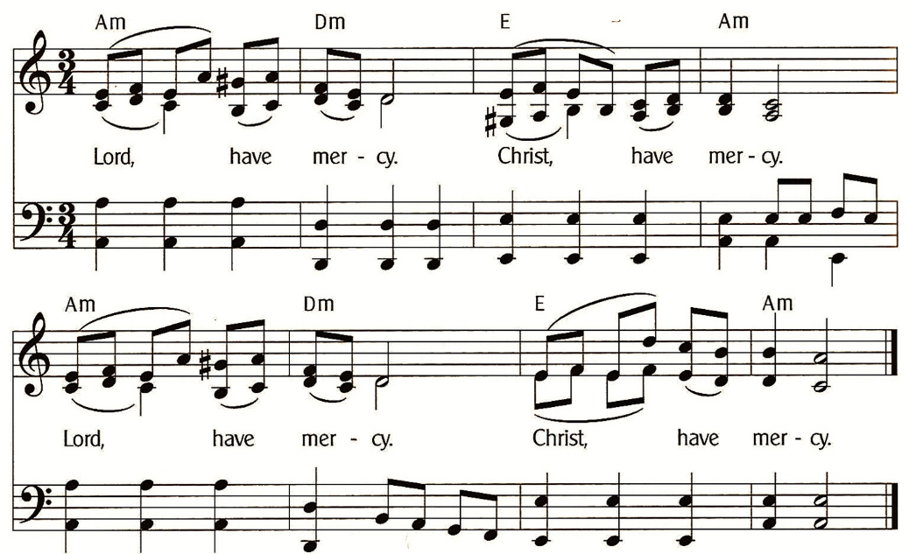

GLORIA IN EXCELSIS (Pastor Only) - Pg 23
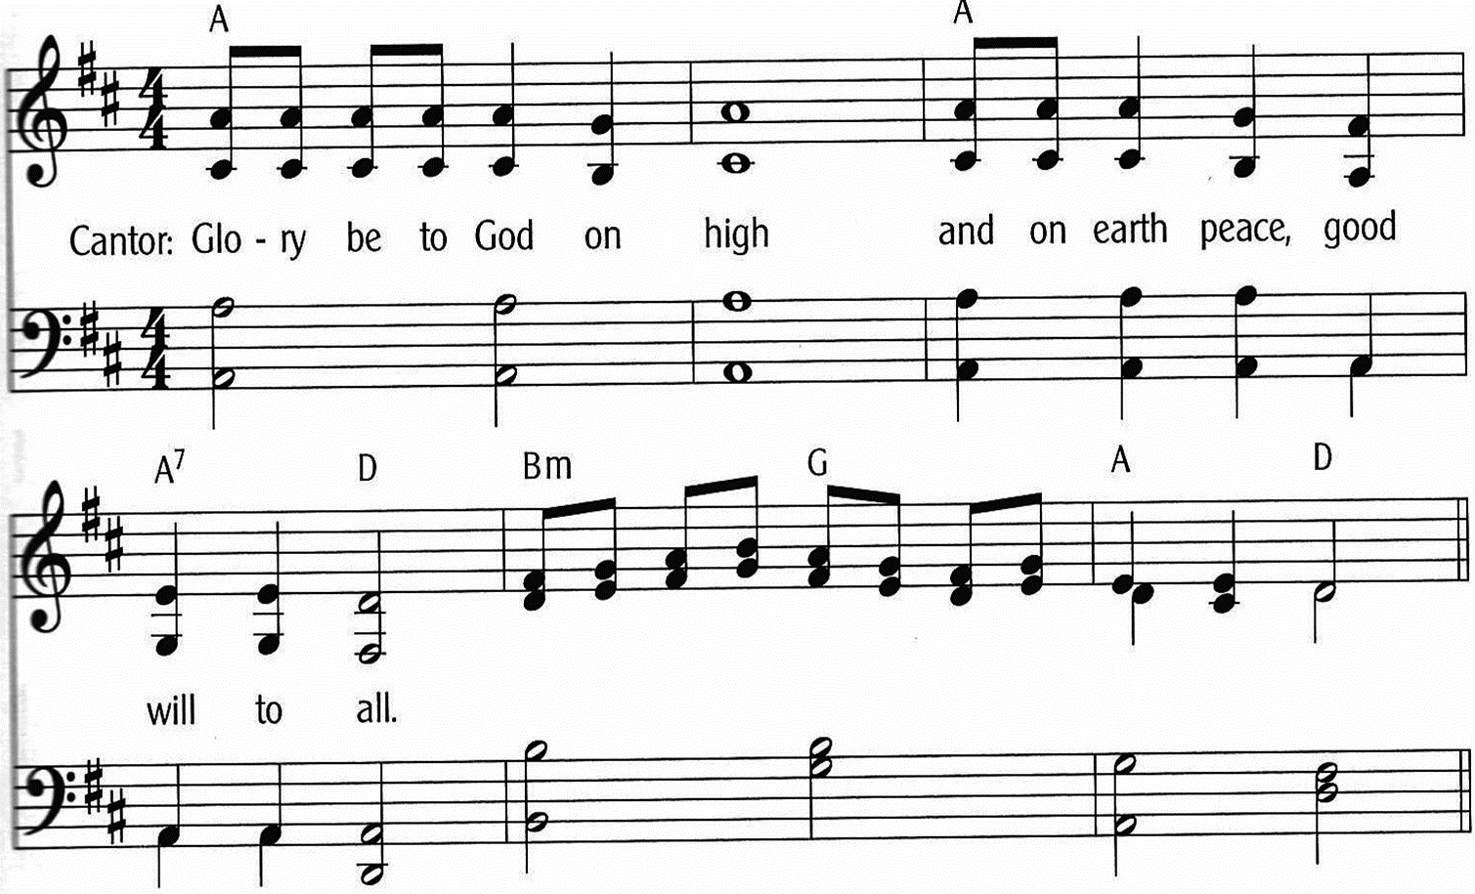
Page 3 of 16
GLORIA IN EXCELSIS - Pg 23-24
(Everyone Sing)
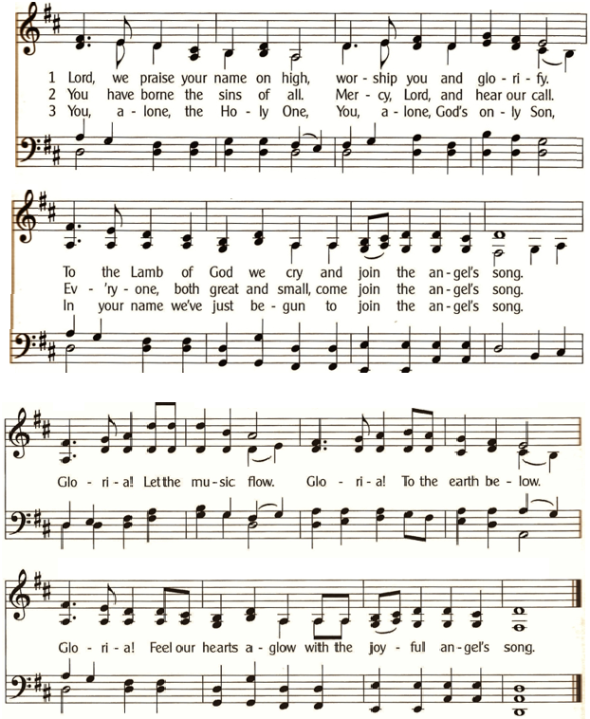

* SALUTATION - Pg 24
P: The Lord be with you.
C: And also with you.

Page 4 of 16
PRAYER OF THE DAY – Pg 24
P: Let us pray: Stand watch over your family, O Lord, that we who depend entirely on your heavenly grace may always be protected in the mighty fortress of your love; through Jesus Christ, your Son, our Lord, who lives and reigns with you and the Holy Spirit, one God, now and forever. C: Amen.

1st LESSON: Isaiah 40:21-31
²¹Do you not know? Do you not hear? Has it not been told you from the beginning? Have you not understood from the foundations of the earth? ²²It is he who sits above the circle of the earth, and its inhabitants are like grasshoppers; who stretches out the heavens like a curtain, and spreads them like a tent to dwell in; ²³who brings princes to nothing, and makes the rulers of the earth as emptiness. ²⁴Scarcely are they planted, scarcely sown, scarcely has their stem taken root in the earth, when he blows on them, and they wither, and the tempest carries them off like stubble. ²⁵To whom then will you compare me, that I should be like him? says the Holy One. ²⁶Lift up your eyes on high and see: who created these? He who brings out their host by number, calling them all by name; by the greatness of his might and because he is strong in power, not one is missing. ²⁷Why do you say, O Jacob, and speak, O Israel, “My way is hidden from the Lord, and my right is disregarded by my God”? ²⁸Have you not known? Have you not heard? The Lord is the everlasting God, the Creator of the ends of the earth. He does not faint or grow weary; his understanding is unsearchable. ²⁹He gives power to the faint, and to him who has no might he increases strength. ³⁰Even youths shall faint and be weary, and young men shall fall exhausted; ³¹but they who wait for the Lord shall renew their strength; they shall mount up with wings like eagles; they shall run and not be weary; they shall walk and not faint.
The Word of the Lord. C: Thanks be to God.

Page 5 of 16
PSALM 147:1-12 (Read Responsively)

¹ Hallelujah! How good it is to sing praises to our God!
How pleasant it is to honor him with praise!

² The Lord rebuilds Jerusalem;
He gathers the exiles of Israel.

³ He heals the brokenhearted
And binds up their wounds.

⁴ He counts the number of the stars
And calls them all by their names.

⁵ Great is our Lord and mighty in power;
There is no limit to his wisdom.

⁶ The Lord lifts up the lowly,
But casts the wicked to the ground.

⁷ Sing to the Lord with thanksgiving;
Make music to our God upon the harp.

⁸ He covers the heavens with clouds
And prepares rain for the earth;

⁹ He makes grass to grow upon the mountains
And green plants to serve mankind.

¹⁰ He provides food for flocks and herds
And for the young ravens when they cry.

¹¹ He is not impressed by the might of a horse;
He has no pleasure in the strength of a man;

¹² But the Lord has pleasure in those who fear him,
In those who await his gracious favor.

Page 6 of 16
2nd LESSON: 1 Corinthians 9:16-27
¹⁶For if I preach the gospel, that gives me no ground for boasting. For necessity is laid upon me. Woe to me if I do not preach the gospel! ¹⁷For if I do this of my own will, I have a reward, but if not of my own will, I am still entrusted with a stewardship. ¹⁸What then is my reward? That in my preaching I may present the gospel free of charge, so as not to make full use of my right in the gospel. ¹⁹For though I am free from all, I have made myself a servant to all, that I might win more of them. ²⁰To the Jews I became as a Jew, in order to win Jews. To those under the law I became as one under the law (though not being myself under the law) that I might win those under the law. ²¹To those outside the law I became as one outside the law (not being outside the law of God but under the law of Christ) that I might win those outside the law. ²²To the weak I became weak, that I might win the weak. I have become all things to all people, that by all means I might save some. ²³I do it all for the sake of the gospel, that I may share with them in its blessings. ²⁴Do you not know that in a race all the runners run, but only one receives the prize? So run that you may obtain it. ²⁵Every athlete exercises self-control in all things. They do it to receive a perishable wreath, but we an imperishable. ²⁶So I do not run aimlessly; I do not box as one beating the air. ²⁷But I discipline my body and keep it under control, lest after preaching to others I myself should be disqualified.
The Word of the Lord. C: Thanks be to God.

HALLELUJAH - Pg 25
Hal-le-lu, Hal-le-lu-Ia. Give Praise to the Lord
For the Bless-ings of Hea-ven in God’s Ho-ly Word.
For the Words of For-give-ness, the Words That En-dure.
Hal-le-lu, Hal-le-lu-Ia. Give Praise to the Lord.

Page 7 of 16
GOSPEL: Mark 1: 29-39
The Gospel is written in the 1st Chapter of St Mark.
C: Glory be to you, O Lord.
²⁹Immediately Jesus left the synagogue and entered the house of Simon and Andrew, with James and John. ³⁰Now Simon’s mother-in-law lay ill with a fever, and immediately they told him about her. ³¹And he came and took her by the hand and lifted her up, and the fever left her, and she began to serve them. ³²That evening at sundown they brought to him all who were sick or oppressed by demons. ³³And the whole city was gathered together at the door. ³⁴And he healed many who were sick with various diseases, and cast out many demons. And he would not permit the demons to speak, because they knew him. ³⁵And rising very early in the morning, while it was still dark, he departed and went out to a desolate place, and there he prayed. ³⁶And Simon and those who were with him searched for him, ³⁷and they found him and said to him, “Everyone is looking for you.” ³⁸And he said to them, “Let us go on to the next towns, that I may preach there also, for that is why I came out.” ³⁹And he went throughout all Galilee, preaching in their synagogues and casting out demons.
The Gospel of the Lord. C: Praise to you, O Christ.

Page 8 of 16
NICENE CREED – Pg 27
C: We Believe in One God, the Father, the Almighty,
Maker of Heaven and Earth, of All That is, Seen and Unseen.
We Believe in One Lord, Jesus Christ, the Only Son of God,
Eternally Begotten of the Father, God from God, Light from Light, True God from True God, Begotten, Not Made,
Of One Being with the Father;
Through Him All Things Were Made.
For Us and For Our Salvation He Came Down from Heaven,
By the Power of the Holy Spirit,
He Became Incarnate from the Virgin Mary and was Made Man
For Our Sake He Was Crucified Under Pontius Pilate;
He Suffered Death and Was Buried.
On the Third Day He Rose Again
In Accordance with the Scriptures; He Ascended into Heaven
And is Seated at the Right Hand of the Father.
He Will Come Again in Glory to Judge the Living and the Dead,
And His Kingdom Will Have No End.
We Believe in the Holy Spirit, the Lord, the Giver of Life,
Who Proceeds from the Father and the Son.
With the Father and the Son, He is Worshiped and Glorified.
He Has Spoken Through the Prophets.
We Believe in One Holy catholic and Apostolic Church.
We Acknowledge One Baptism for the Forgiveness of Sins.
We Look for the Resurrection of the Dead,
And the Life of the World to Come. Amen.

****** Sermon: Rev John Saethre ******

Page 9 of 16
Break Thou the Bread of Life - #85

V1 Break Thou the Bread of Life, Dear Lord, to Me.
As Thou Didst Break the Loaves Be-side the Sea.
Be-yond the Sa-cred Page, I Seek Thee, Lord.
My Spir-it Pants for Thee, O Liv-ing Word.

V2 Bless Thou the Truth, Dear Lord, To Me, to Me.
As Thou Didst Bless the Bread By Ga-li-lee.
Then Shall All Bond-age Cease, All Fet-ters Fall.
And I Shall Find My Peace, My All-in-All.

********** NO Sharing the Peace **********

(Offerings Gathered & Presented) – Pg 28

PRAYERS OF THE CHURCH – Pg 29
Let us pray for the whole people of God in Christ Jesus, and for all people according to their needs.
For Tender Care
Tender Lord of Mercy, you know our deepest thoughts and fears that sometimes get in the way of spending time with you; help us to remember that you alone can sustain us through whatever we are facing. Help us remember that it is through our times of trial where we can learn to trust you and be a witness to your healing power. We pray that the church would be a beacon of hope to the world with all its concerns.
Lord, in your mercy, C: Hear our prayer.
For Prayerfulness
Gracious Father, we don’t always seek you first in times of gratitude, trouble, or counsel. We ask today that we would be ever mindful that you are always here for us. We also pray for those who don’t know you; may we be a light of hope to them through our prayers, words, and deeds. We ask that you would pour out your Holy Spirit upon us that we may know what we are to pray at all times and in all situations.
Lord, in your mercy, C: Hear our prayer.
Page 10 of 16
For the Lonely
Heavenly Father, we know that there are countless people who live among us that feel lonely or uncared for in this world. We pray, as your church, that we would intentionally work to find them through our ministries. Let us be your hands and feet in the world, to serve others as you would have us do.
Lord, in your mercy, C: Hear our prayer.
For Healing Endurance
Father God, we pray for those who are sick, hospitalized, preparing for surgery, or suffering in any way. We especially remember silently or aloud: [NAMES]
We pray they will be consoled and strengthened to endure through their faith in Jesus Christ our Lord and Savior. We also pray for their loved ones that they find comfort through you.
Lord, in your mercy, C: Hear our prayer.

P: Into your hands, almighty God, we commend all for whom we pray; trusting in your abundant mercy, through Jesus Christ, our Savior. C: Amen.

EXHORTATION – Pg 32
Brothers and sisters in Christ, to receive this Holy Sacrament in a worthy manner, consider what we must now believe and do.
We should believe that Jesus Christ himself is truly present in the bread and wine as his words declare: “This is my body, which is given for you; this is my blood, which is shed for you for the forgiveness of sin.”
We should also trust the Jesus Christ forgives our sins as his words promise: “for the forgiveness of sin.”
Finally, we should do as Christ commands when he says: “Take. Eat. Drink. Do this in remembrance of me.”
When we repent, believe these words, and do as Christ commands, then we have rightly examined ourselves and worthily come to the Lord’s table for the forgiveness of all our sins.
Page 11 of 16
Together, we should also give thanks to the Father of our Lord Jesus Christ for this great gift. We should love one another with a pure heart, and with the whole Christian church take comfort and joy in Christ our Lord. May our heavenly Father grant us his grace; through our lord Jesus Christ. Amen.

PREFACE – Pg 33

P: The Lord be with you.
C: And also with you.

P: Lift up your hearts.
C: We lift them to the Lord.

P: Let us give thanks to the Lord, our God.
C: It is right to give him thanks and praise.

P: It is truly good, right and salutary that we should at all times and in all places give thanks to you, O Lord, holy Father, almighty everlasting God. And now we praise you, that you have sent to us your only begotten Son, and that in Him, being found in the form of a man, you have revealed the fullness of your glory. Therefore, with angels and archangels, and with all the company of heaven, we laud and magnify your glorious name, evermore praising you and saying:

SANTUS (Saint) – Pg 35
C: Ho-ly, ho-ly, ho-ly, God of pow-er almighty.
Hea-ven and earth are full of your glo-ry,
Ho-san-na in the high-est.
Bless-ed is he who comes in the name of the Lord.
Ho-san-na in the high-est.
Ho-san-na in the high-est.

Page 12 of 16
LORD’S PRAYER - Pg 36
Our Father, Who Art in Heaven,
Hallowed Be Thy Name,
Thy Kingdom Come, Thy Will Be Done,
On Earth as it is in Heaven.
Give Us This Day Our Daily Bread.
And Forgive Us Our Trespasses,
As We Forgive Those Who Trespass Against Us.
And Lead Us Not into Temptation,
But Deliver Us From Evil.
For Thine is the Kingdom,
And the Power, and the Glory,
Forever and Ever. Amen

WORDS OF INSTITUTION – Pg 37
Our Lord Jesus Christ, on the night in which he was betrayed, took bread, and when he had given thanks, he broke it and gave it to his disciples, saying, “Take, eat, this is my body which is given for you. Do this for the remembrance of me.”
Again, after supper he took the cup, gave thanks, and gave it to them saying: “Take , and drink of it, all of you. This cup is the new testament in my blood, which is shed for you and for many for the forgiveness of sins. Do this, as often as you drink it, in remembrance of me.”

AGNUS DEI (Lamb of God) – Pg 37
(MarJean Solo)
Lamb of God, You Take the Sins of the World,
Lamb of God, Your Mer-cies never cease.
Lamb of God, You Take the Sins of the World,
Jesus Christ, Lamb of God, You give us Peace.

Page 13 of 16
COMMUNION INSTITUTION – Pg 37
P: The body of Christ, given for you.
P: The blood of Christ, shed for you.

TABLE BLESSING – Pg 37
The body of our Lord Jesus Christ and his precious blood strengthen and preserve you in true faith to everlasting life. C: Amen.

NUNC DIMITTIS (Now Release) – Pg 38
C: Lord, now let your servant depart in peace, according to your word. For my eyes have seen your salvation, which you have prepared before the face of all people. A light to lighten the Gentiles and the glory of your people Israel. Glory be to the Father, and to the Son, and to the Holy Spirit. As it was in the beginning, is now, and ever shall be, world without end. Amen.

THANKSGIVING – Pg 38
P: We give you thanks, almighty God, that you have refreshed us through this your salutary gift, and we ask you in your mercy to strengthen us through the same in faith toward you and in fervent love toward one another, through Jesus Christ, your dear Son, our Lord, who lives and reigns with you and the Holy Spirit, one God, world without end. C: Amen.

BENEDICAMUS - Pg 38

P: The Lord be With You.
C: And also with you.

P: Bless the Lord.
C: Thanks be to God.

Page 14 of 16
*Benediction – Pg 38
P: As you go, may God go with you;
May He go before you to show you the way;
May He go behind you encourage you;
May He go beside you to befriend you;
Above you to watch over you;
And within you to grant you His eternal peace.
In the Name of the Father, and of the Son,
And of the Holy Spirit.
C: Amen.

Lord, with Grateful Hearts – #51

Verse 1
Lord, with Grate-ful Hearts We Share Your Faith-ful-ness.
In Your Word is Our Con-fi-dence.
We’re Per-suad-ed by Your Truth and Righ-teous-ness.
You Have Hon-ored Your Cov-e-nant.
Thank You, God Al-might-y. Thank You, God Al-might-y.
Might-y is the Lord Who Gives Us Life and Health.
Verse 2
O You Joy-ful Peo-ple, O You Hap-py Ones.
God Has Taught You the Fes-tal Shout.
Hon-or, Jus-tice and Re-spect All Righ-teous-ness.
Dance and Sing with a Joy-ful Sound.
Thank You, God Al-might-y. Thank You, God Al-might-y.
Might-y is the Lord Who Gives Us Life and Health.

Page 15 of 16
Welcome To Emmanuel Lutheran – N.A.L.C.
Thanks for worshiping with us this evening. Your presence is your gift to us. We pray that our Service of Worship is a blessing to you. Sealed by the Holy Spirit and marked with the cross of Christ forever we are -- praising, proclaiming and practicing -- Emmanuel, God with us, in daily life!

Emmanuel Lutheran Church Emmanuel North
3819 - 18th Avenue NW 1965 Emmanuel Dr NW
Rochester, MN 55901 (7601 - 18th Ave NW)
Phone: 507-206-3048
Website: www.emmanuelofrochester.org
Email Address: EmmanuelRochesterNALC@gmail.com
Facebook page: Emmanuel Lutheran Church of Rochester, MN

Men’s Bible Study
Men meet at Oasis Church each Wednesday at 11am, Feb 7th, 14th, 21st & 28th and Mar 6th, 13th, 20th & 27th to study the Scriptures.

Women’s Bible Study
Women meet at Oasis Church every other Wednesday at 1pm, Feb 7th & 21st and Mar 6th, & 20th to study “Chasing Vines” by Beth Moore.

Thrivent Choice Dollars
If You Have Thrivent Products, Call 1-800-847-4836 or go online, www.thrivent.org and Designate Your “Choice Dollars”.

Lenten Series
Lent begins early in 2024 – Ash Wednesday is February 14th. Rev John Saethre will be doing a series entitled, “Hands Across the Cross” at our mid-week Lenten services. And we will be using the Holden Evening Prayer order of service.

Page 16 of 16

