Worship – Eve of Easter 5 Sat, Apr 27th, 2024 – 4pm
Pastor: Rev John Saethre Reclaim Hymnal
Pianist: Mary Ann Groven Setting 1
Reader: Karl Saethre * indicates stand if able

*Confession of Sin - Pg 21
P: In the name of the Father and of the Son and of the Holy Spirit. C: Amen.

P: Beloved in the Lord. Let us draw near with a true heart and confess our sin to God our Father, imploring Him, in the name of our Lord Jesus Christ, to grant us forgiveness.

P: Our help is in the name of the Lord.
C: Who made heaven and earth.

P: I said I will confess my transgressions to the Lord.
C: And you forgave the iniquity of my sin.

(Time for silent reflection)

P: Almighty God, our Maker and Redeemer, we poor sinners confess to you that we are by nature sinful and unclean and that we have sinned against you in thought, word, and deed. Therefore, we flee for refuge to your infinite mercy, seeking and imploring your grace for the sake of your Son, Jesus Christ our Lord.

Page 1 of 16
C: Most merciful God, you have given your only Son to die for us. Have mercy on us, and for his sake grant us remission of all our sins. By your Holy Spirit, increase in us true knowledge of you and of your will and true obedience to your word, so that by your grace we may come to everlasting life, through Jesus Christ our Lord. Amen.
Absolution - Pg 21
P: Almighty God, our heavenly Father, has had mercy on us and has given his only Son to die for us and for his sake forgives us all our sins. To all who believe in his name, he gives power to become children of God and bestows on them his Holy Spirit. All who believe and are baptized shall be saved. Grant this, O Lord, unto us all.
C: Amen.

Come, Thou Fount of Every Blessing #227

V1 Come, Thou Fount of Ev-'ry Bless-ing,
Tune My Heart to Sing Thy Grace.
Streams of Mer-cy, Nev-er Ceas-ing,
Call for Songs of Loud-est Praise.
While the Hope of End-less Glo-ry
Fills My Heart with Joy and Love,
Teach Me Ev-er to A-dore Thee.
May I Still Thy Good-ness Prove.

V2 Here I Raise My Eb-en-e-zer
Hith-er by Thy Help I'm Come.
And I Hope, by Thy Good Plea-sure,
Safe-ly to Ar-rive at Home.
Je-sus Sought Me When a Strang-er,
Wan-d'ring from the Fold of God.
He, to Res-cue Me from Dan-ger,
In-ter-posed His Pre-cious Blood.

Page 2 of 16
V3 Oh, to Grace How Great a Debt-or
Dai-ly I'm Con-strained to Be.
Let That Grace Now Like a Fet-ter
Bind My Wan-d'ring Heart to Thee.
Prone to Wan-der, Lord, I Feel It.
Prone to Leave the God I Love.
Here's My Heart, oh, Take and Seal it.
Seal it For Thy Courts A-bove.

*Greeting – Pg 22
P: The grace of our Lord Jesus Christ, the love of God
and the Communion of the Holy Spirit Be with you all.
C: And also with you.

*Kyrie Eleison - Pg 22
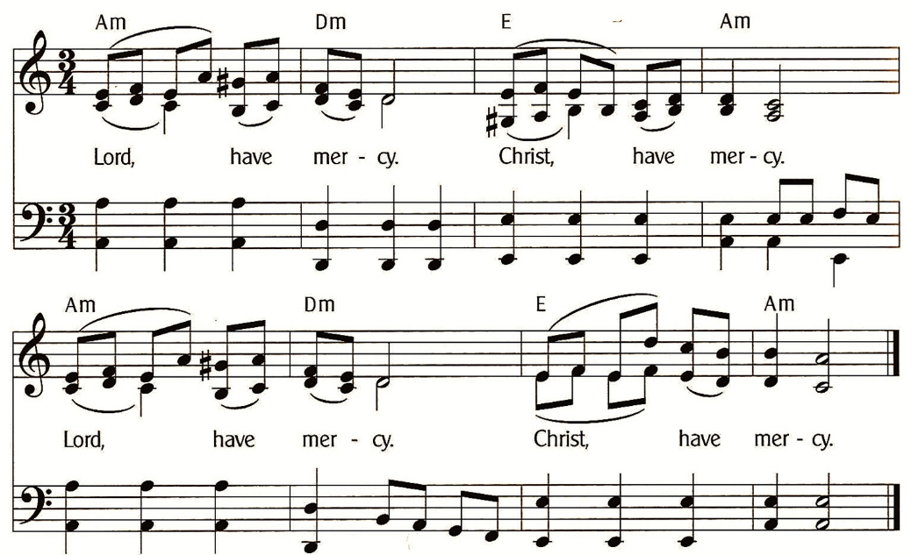

Page 3 of 16
Gloria In Excelsis (Pastor Only) - Pg 23
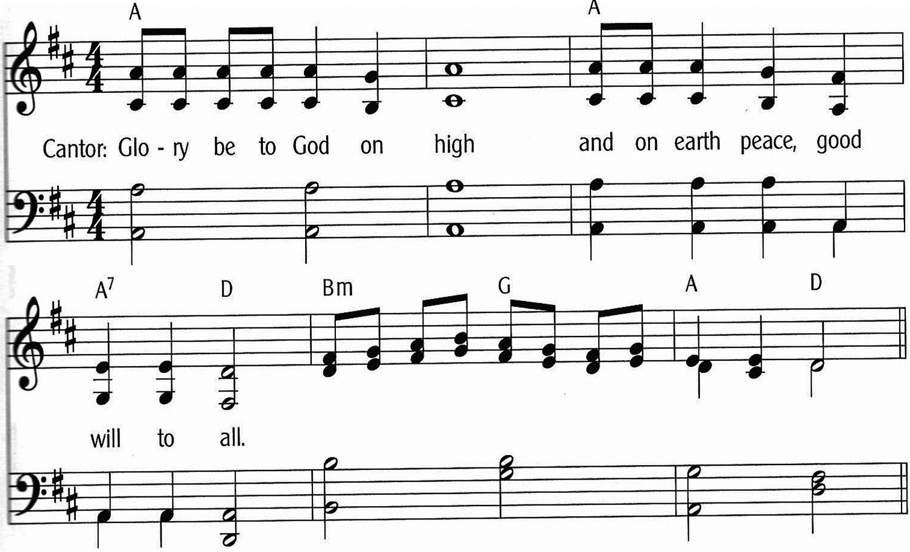

Page 4 of 16
Gloria In Excelsis - Pg 23-24
(Everyone Sing)
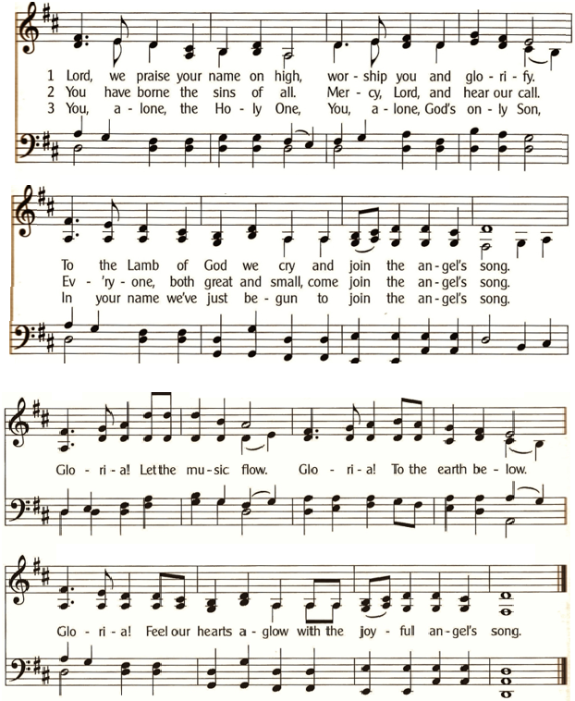

* Salutation - Pg 24
P: The Lord be with you.
C: And also with you.

Page 5 of 16
Prayer of the Day – Pg 24
P: Let us pray: O God, you make the minds of the faithful to be of one will. Grant that your people would love what you command and desire what you promise, that, among the manifold changes of this world, our hearts may be fixed where true joys are to be found; through your Son, Jesus Christ, our Lord, who lives and reigns with you and the Holy Spirit, one God, now and forever. C: Amen.

In the Garden #160
Verse 1
I Come to the Gar-den A-lone,
While the Dew is Still on the Ros-es.
And the Voice I Hear, Fall-ing on My Ear,
The Son of God Dis-clos-es.
Refrain
And He Walks with Me, and He Talks with Me,
And He Tells Me I Am His Own.
And the Joy We Share as We Tar-ry There,
None Other Has Ev-er Known.

Verse 2
He Speaks, and the Sound of His Voice
Is so Sweet the Birds Hush Their Sing-ing.
And the Mel-o-dy That He Gave to Me
With-in My Heart is Ring-ing.
(Repeat Refrain)

Verse 3
I'd Stay in the Gar-den with Him
Tho' the Night A-round Me be Fall-ing,
But He Bids Me Go, Thro' the Voice of Woe,
His Voice to Me is Call-ing.
(Repeat Refrain)

Page 6 of 16
1st Lesson: Acts 8:26-40
²⁶An angel of the Lord said to Philip, “Rise and go toward the south to the road that goes down from Jerusalem to Gaza.” This is a desert place. ²⁷And he rose and went. And there was an Ethiopian, a eunuch, a court official of Candace, queen of the Ethiopians, who was in charge of all her treasure. He had come to Jerusalem to worship ²⁸and was returning, seated in his chariot, and he was reading the prophet Isaiah. ²⁹And the Spirit said to Philip, “Go over and join this chariot.” ³⁰So Philip ran to him and heard him reading Isaiah the prophet and asked, “Do you understand what you are reading?” ³¹And he said, “How can I, unless someone guides me?” And he invited Philip to come up and sit with him. ³²Now the passage of the Scripture that he was reading was this: “Like a sheep he was led to the slaughter and like a lamb before its shearer is silent, so he opens not his mouth. ³³In his humiliation justice was denied him. Who can describe his generation? For his life is taken away from the earth.” ³⁴And the eunuch said to Philip, “About whom, I ask you, does the prophet say this, about himself or about someone else?” ³⁵Then Philip opened his mouth, and beginning with this Scripture he told him the good news about Jesus. ³⁶And as they were going along the road they came to some water, and the eunuch said, “See, here is water! What prevents me from being baptized?” ³⁸And he commanded the chariot to stop, and they both went down into the water, Philip and the eunuch, and he baptized him. ³⁹And when they came up out of the water, the Spirit of the Lord carried Philip away, and the eunuch saw him no more, and went on his way rejoicing. ⁴⁰But Philip found himself at Azotus, and as he passed through he preached the gospel to all the towns until he came to Caesarea.
The Word of the Lord. C: Thanks be to God.

Page 7 of 16

Psalm 150 (Read Responsively)

¹ Hallelujah! Praise God in his holy temple;
Praise him in the firmament of his power.

² Praise him for his mighty acts;
Praise him for his excellent greatness.

³ Praise him with the blast of the ram’s horn;
Praise him with lyre and harp.

⁴ Praise him with timbrel and dance;
Praise him with strings and pipe.

⁵ Praise him with resounding cymbals;
Praise him with loud clanging cymbals.

⁶ Let everything that has breath
Praise the Lord. Hallelujah!

2nd Lesson: 1 John 4:1-21
¹Beloved, do not believe every spirit, but test the spirits to see whether they are from God, for many false prophets have gone out into the world. ²By this you know the Spirit of God: every spirit that confesses that Jesus Christ has come in the flesh is from God, ³and every spirit that does not confess Jesus is not from God. This is the spirit of the antichrist, which you heard was coming and now is in the world already. ⁴Little children, you are from God and have overcome them, for he who is in you is greater than he who is in the world. ⁵They are from the world; therefore they speak from the world, and the world listens to them. ⁶We are from God. Whoever knows God listens to us; whoever is not from God does not listen to us. By this we know the Spirit of truth and the spirit of error. ⁷Beloved, let us love one another, for love is from God, and whoever loves has been born of God and knows God. ⁸Anyone who does not love does not know God, because God is love.
Page 8 of 16
⁹In this the love of God was made manifest among us, that God sent his only Son into the world, so that we might live through him. ¹⁰In this is love, not that we have loved God but that he loved us and sent his Son to be the propitiation for our sins. ¹¹Beloved, if God so loved us, we also ought to love one another. ¹²No one has ever seen God; if we love one another, God abides in us and his love is perfected in us. ¹³By this we know that we abide in him and he in us, because he has given us of his Spirit. ¹⁴And we have seen and testify that the Father has sent his Son to be the Savior of the world. ¹⁵Whoever confesses that Jesus is the Son of God, God abides in him, and he in God. ¹⁶So we have come to know and to believe the love that God has for us. God is love, and whoever abides in love abides in God, and God abides in him. ¹⁷By this is love perfected with us, so that we may have confidence for the day of judgment, because as he is so also are we in this world. ¹⁸There is no fear in love, but perfect love casts out fear. For fear has to do with punishment, and whoever fears has not been perfected in love. ¹⁹We love because he first loved us. ²⁰If anyone says, “I love God,” and hates his brother, he is a liar; for he who does not love his brother whom he has seen cannot love God whom he has not seen. ²¹And this commandment we have from him: whoever loves God must also love his brother.
The Word of the Lord. C: Thanks be to God.

Hallelujah - Pg 25
Hal-le-lu, Hal-le-lu-Ia. Give Praise to the Lord
For the Bless-ings of Hea-ven in God’s Ho-ly Word.
For the Words of For-give-ness, the Words That En-dure.
Hal-le-lu, Hal-le-lu-Ia. Give Praise to the Lord.

Page 9 of 16
Gospel: John 15:1-8
The Gospel is written in the 15th Chapter of St John.
C: Glory be to you, O Lord.
¹Jesus said, “I am the true vine, and my Father is the vinedresser. ²Every branch in me that does not bear fruit he takes away, and every branch that does bear fruit he prunes, that it may bear more fruit. ³Already you are clean because of the word that I have spoken to you. ⁴Abide in me, and I in you. As the branch cannot bear fruit by itself, unless it abides in the vine, neither can you, unless you abide in me. ⁵I am the vine; you are the branches. Whoever abides in me and I in him, he it is that bears much fruit, for apart from me you can do nothing. ⁶If anyone does not abide in me he is thrown away like a branch and withers; and the branches are gathered, thrown into the fire, and burned. ⁷If you abide in me, and my words abide in you, ask whatever you wish, and it will be done for you. ⁸By this my Father is glorified, that you bear much fruit and so prove to be my disciples.”
The Gospel of the Lord. C: Praise to you, O Christ.

Apostles’ Creed - Pg 28
I Believe in God, the Father Almighty,
Creator of Heaven and Earth.
I Believe in Jesus Christ, His Only Son, Our Lord.
He Was Conceived by the Power of the Holy Spirit
And Born of the Virgin Mary.
He Suffered Under Pontius Pilate,
Was Crucified, Died, and Was Buried. He Descended into Hell.
On the Third Day He Rose Again. He Ascended into Heaven,
And is Seated at the Right Hand of the Father.
He Will Come Again to Judge the Living and the Dead.
I Believe in the Holy Spirit, the Holy Christian Church,
The Communion of Saints, the Forgiveness of Sins,
The Resurrection of the Body, and the Life Everlasting. Amen.

Page 10 of 16
****** Sermon: Rev John Saethre ******

Jesus Keep Me Near the Cross #158 (V.1,3,4)

V1 Je-sus, Keep Me Near the Cross,
There a Pre-cious Foun-tain,
Free to All, a Heal-ing Stream,
Flows from Cal-v’ry’s Moun-tain.
In the Cross, in the Cross,
Be My Glo-ry Ev-er.
Till My Rap-tured Soul Shall Find
Rest Be-yond the Riv-er.

V3 Near the Cross, O Lamb of God,
Bring its Scenes Be-fore Me.
Help Me Walk from Day to Day,
With its Shad-ows O’er Me.
In the Cross, in the Cross,
Be My Glo-ry Ev-er.
Till My Rap-tured Soul Shall Find
Rest Be-yond the Riv-er.

V4 Near the Cross I’ll Watch and Wait,
Hop-ing, Trust-ing Ev-er,
Till I Reach the Gold-en Strand,
Just Be-yond the Riv-er.
In the Cross, in the Cross,
Be My Glo-ry Ev-er.
Till My Rap-tured Soul Shall Find
Rest Be-yond the Riv-er.

Sharing the Peace
P: The peace of the Lord be with you always.
C: And also with you.

**** (Offerings Gathered & Presented) ****

Page 11 of 16
Prayers of the Church – Pg 29
Let us pray for the whole people of God in Christ Jesus, and for all people according to their needs. (Brief Silence)

For Bearing Fruit and Abiding
Holy God, through your son, Jesus, we abide in you. Help us to bear fruit as we seek to serve our neighbor. Grant us courage and strength so when we are pruned by the vinedresser, we not only glorify your Son, but bear even more fruit. We give you thanks and praise for your Son, who has made it possible for us to be together with you.
Lord, in your mercy, C: Hear our prayer.

For the Alpha and Omega
Eternal Lord, you are the Alpha and Omega, the beginning and end of all that exists. Bring joy to families who are welcoming babies into their lives, so they might cherish every moment together. Bring comfort to those who grieve the loss of loved ones, assuring them of the sure and certain hope of the resurrection.
Lord, in your mercy, C: Hear our prayer.

For the Beauty of Creation
O Lord our God, we give you thanks for the beauty of your creation: for budding trees and blooming flowers, for a renewal of life on this planet. May we be good stewards of all the resources you have given, especially water, land, and food. May our care for the world you created be a sign of our devotion to you.
Lord, in your mercy, C: Hear our prayer.

Page 12 of 16
For Healing and Renewal
Lord of life, you are the source of all healing and rest. Grant your healing mercy to be with all those who struggle with pain or suffering. Surround them with your comfort. Lord, bring hope to the hopeless and provide for the needs of your people each day. We especially remember silently or aloud: [NAMES]
Lord, in your mercy, C: Hear our prayer.

P: Into your hands, almighty God, we commend all for whom we pray; trusting in your abundant mercy, through Jesus Christ, our Savior. C: Amen.

Lord’s Prayer - Pg 36
Our Father, Who Art in Heaven,
Hallowed Be Thy Name,
Thy Kingdom Come, Thy Will Be Done,
On Earth as it is in Heaven.
Give Us This Day Our Daily Bread.
And Forgive Us Our Trespasses,
As We Forgive Those Who Trespass Against Us.
And Lead Us Not into Temptation,
But Deliver Us From Evil.
For Thine is the Kingdom,
And the Power, and the Glory,
Forever and Ever. Amen.

*Benediction – Pg 38
P: As you go, may God go with you;
May He go before you to show you the way;
May He go behind you encourage you;
May He go beside you to befriend you;
Above you to watch over you;
And within you to grant you His eternal peace.
In the Name of the Father, and of the Son,
and of the Holy Spirit. C: Amen.
Page 13 of 16
My Faith Looks Up to Thee #243

V1 My Faith Looks Up to Thee,
Thou Lamb of Cal-va-ry,
Sav-ior Di-vine.
Now Hear Me While I Pray.
Take All My Guilt A-way,
Oh, Let Me from This Day
Be Whol-ly Thine.

V2 May Thy Rich Grace Im-part
Strength to My Faint-ing Heart,
My Zeal In-spire.
As Thou Hast Died for Me,
Oh, May My Love to Thee
Pure, Warm, and Change-less Be,
A Liv-ing Fire.

V3 While Life’s Dark Maze I Tread
And Griefs A-round Me Spread,
Be Thou My Guide.
Bid Dark-ness Turn to Day,
Wipe Sor-row’s Tears A-way,
Nor Let Me Ev-er Stray
From Thee A-side.

V4 When Ends Life's Tran-sient Dream,
When Death’s Cold, Sul-len Stream
Shall Oe'r Me Roll.
Blest Sav-ior, Then, in Love
Fear and Dis-trust Re-move.
Oh, Bear Me Safe A-bove,
A Ran-somed Soul.

Dismissal
P: Go in Peace, Serve the Lord.
C: Thanks be to God!
Page 14 of 16
Calendar Items
Wed, May 1 Men’s Bible Study - 11am at Oasis
Sat, May 4 Eve of Easter 6 Service w/Communion - 4pm
Tue, May 7 Council Meeting – 4pm at Emmanuel North
Wed, May 8 Men’s Bible Study - 11am at Oasis
-and- Women’s Bible Study – 1pm at Oasis
Sat, May 11 Ascension / Easter 7 Worship Service - 4pm
Sun, May 12 MOTHER’S DAY
Wed, May 15 Men’s Bible Study - 11am at Oasis
Sat, May 18 Eve of Pentecost Service w/Communion 4pm
Wed, May 22 Men’s Bible Study - 11am at Oasis
-and- Women’s Bible Study – 1pm at Oasis
Sat, May 25 Eve of Holy Trinity Worship Service - 4pm
Mon, May 27 MEMORIAL DAY
Wed, May 29 Men’s Bible Study - 11am at Oasis
Sat, Jun 1 Eve of Pentecost 2 Srvce w/Communion - 4pm
Wed, Jun 5 Men’s Bible Study - 11am at Oasis
Sat, Jun 8 Eve of Pentecost 3 Service - 4pm

Next Saturday
Next week (Saturday) we will have our regular worship service with Holy Communion at Emmanuel North at 4pm.
A movie will follow the service with treats.

Page 15 of 16
Welcome To Emmanuel Lutheran – N.A.L.C.
Thanks for worshiping with us this evening. Your presence is your gift to us. We pray that our Service of Worship is a blessing to you. Sealed by the Holy Spirit and marked with the cross of Christ forever we are -- praising, proclaiming and practicing -- Emmanuel, God with us, in daily life!

Emmanuel Lutheran Church Emmanuel North
3819 - 18th Avenue NW 1965 Emmanuel Dr NW
Rochester, MN 55901 (7601 - 18th Ave NW)
Phone: 507-206-3048
Website: www.emmanuelofrochester.org
Email Address: EmmanuelRochesterNALC@gmail.com
Facebook page: Emmanuel Lutheran Church of Rochester, MN

Men’s Bible Study
Men meet at Oasis Church each Wednesday at 11am, May 1st, 8th, 15th, 22nd & 29th and Jun 5th studying Scripture.
Women’s Bible Study
Women meet at Oasis Church every other Wednesday at 1pm, May 8th & 22nd to study “Chasing Vines” by Beth Moore.
Thrivent Choice Dollars
If You Have Thrivent Products, go Online to www.thrivent.org or Call 1-800-847-4836 to Designate Your “Choice Dollars”.

Page 16 of 16

