Worship – Eve of Easter 4 Sat, Apr 20th, 2024 – 4pm
Pastor: Rev Doug Hedman Reclaim Hymnal
Pianist: MarJean Damerval Setting 1 & Communion
Reader: Darald Bothun * indicates stand if able

*Confession of Sin - Pg 21
P: In the name of the Father and of the Son and of the Holy Spirit. C: Amen.

P: Beloved in the Lord. Let us draw near with a true heart and confess our sin to God our Father, imploring Him, in the name of our Lord Jesus Christ, to grant us forgiveness.

P: Our help is in the name of the Lord.
C: Who made heaven and earth.

P: I said I will confess my transgressions to the Lord.
C: And you forgave the iniquity of my sin.

(Time for silent reflection)

P: Almighty God, our Maker and Redeemer, we poor sinners confess to you that we are by nature sinful and unclean and that we have sinned against you in thought, word, and deed. Therefore, we flee for refuge to your infinite mercy, seeking and imploring your grace for the sake of your Son, Jesus Christ our Lord.

Page 1 of 16
C: Most merciful God, you have given your only Son to die for us. Have mercy on us, and for his sake grant us remission of all our sins. By your Holy Spirit, increase in us true knowledge of you and of your will and true obedience to your word, so that by your grace we may come to everlasting life, through Jesus Christ our Lord. Amen.
Absolution - Pg 21
P: Almighty God, our heavenly Father, has had mercy on us and has given his only Son to die for us and for his sake forgives us all our sins. To all who believe in his name, he gives power to become children of God and bestows on them his Holy Spirit. All who believe and are baptized shall be saved. Grant this, O Lord, unto us all.
C: Amen.

Gathering Hymn: He Leadeth Me #232
V1 He Lead-eth Me, Oh, Bless-ed Thought.
Oh, Words with Heav'n-ly Com-fort Fraught
What-e'er I Do, Wher-e'er I Be,
Still 'Tis God's Hand That Lead-eth Me.
He Lead-eth Me, He Lead-eth Me,
By His Own Hand He Lead-eth Me.
His Faith-ful Fol-l'wer I Would Be,
For By His Hand He Lead-eth Me.
V2 Some-times Mid Scenes of Deep-est Gloom,
Some-times Where E-den's Bowers Bloom,
By Wa-ters Calm, O'er Trou-bled Sea,
Still 'Tis God's Hand That Leadeth Me.
He Lead-eth Me, He Lead-eth Me,
By His Own Hand He Lead-eth Me.
His Faith-ful Fol-l'wer I Would Be,
For By His Hand He Lead-eth Me.

Page 2 of 16
V3 Lord, I Would Clasp Thy Hand in Mine,
Nor Ev-er Mur-mur Nor Re-pine.
Con-tent, What-ev-er Lot I See,
Since 'Tis My God That Lead-eth Me.
He Lead-eth Me, He Lead-eth Me,
By His Own Hand He Lead-eth Me.
His Faith-ful Fol-l'wer I Would Be,
For By His Hand He Lead-eth Me.
V4 And When My Task on Earth is Done,
When By Thy Grace the Vic-t'ry's Won,
E'en Death's Cold Wave I Will Not Flee,
Since God Through Jor-dan Lead-eth Me.
He Lead-eth Me, He Lead-eth Me,
By His Own Hand He Lead-eth Me.
His Faith-ful Fol-l'wer I Would Be,
For By His Hand He Lead-eth Me.

*Greeting – Pg 22
P: The grace of our Lord Jesus Christ, the love of God
and the Communion of the Holy Spirit Be with you all.
C: And also with you.

Page 3 of 16
*Kyrie Eleison (Lord, Have Mercy) - Pg 22

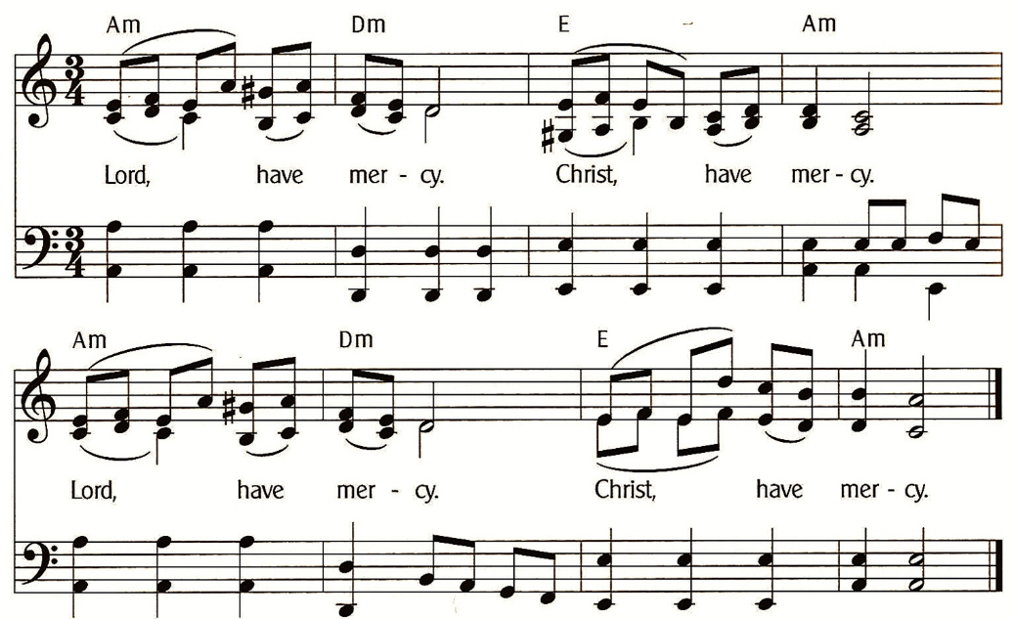

Gloria in Excelsis (Pastor Only) - Pg 23

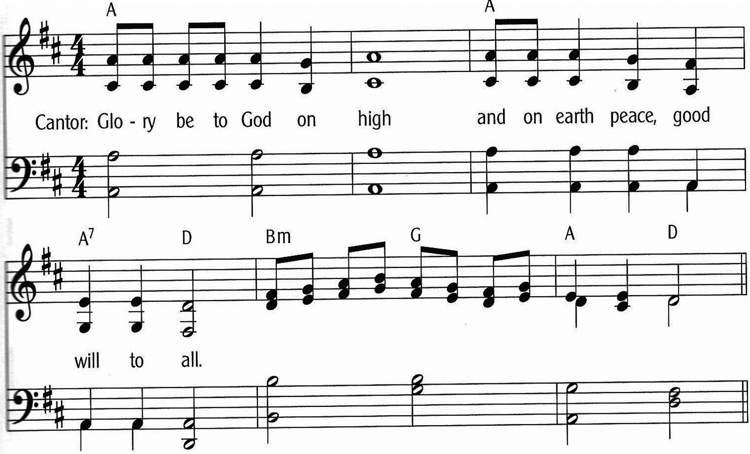

Page 4 of 16
Gloria in Excelsis (Everyone Sing) - Pg 23-24

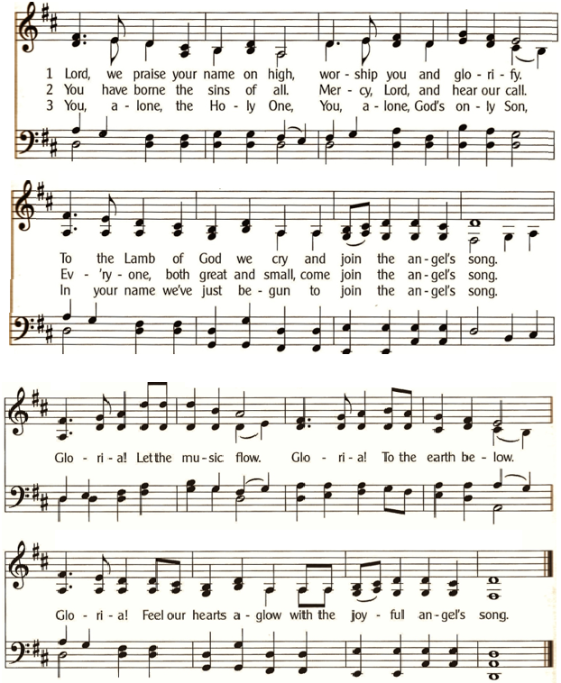

* Salutation - Pg 24
P: The Lord be with you.
C: And also with you.

Page 5 of 16
Prayer of the Day – Pg 24
P: Let us pray: Almighty God, you show those in error the light of your truth, that they may return into the way of righteousness. Grant to all who are admitted into fellowship with Christ the power to avoid all things that are contrary to the faith and to follow you according to the will of your Son, Jesus Christ, our Lord, who lives and reigns with you and the Holy Spirit, one God, now and forever. C: Amen.

1st Lesson: Acts 4:1-12
¹As Peter and John were speaking to the people, the priests and the captain of the temple and the Sadducees came upon them, ²greatly annoyed because they were teaching the people and proclaiming in Jesus the resurrection from the dead. ³And they arrested them and put them in custody until the next day, for it was already evening. ⁴But many of those who had heard the word believed, and the number of the men came to about five thousand. ⁵On the next day their rulers and elders and scribes gathered together in Jerusalem, ⁶with Annas the high priest and Caiaphas and John and Alexander, and all who were of the high-priestly family. ⁷And when they had set them in the midst, they inquired, “By what power or by what name did you do this?” ⁸Then Peter, filled with the Holy Spirit, said to them, “Rulers of the people and elders, ⁹if we are being examined today concerning a good deed done to a crippled man, by what means this man has been healed, ¹⁰let it be known to all of you and to all the people of Israel that by the name of Jesus Christ of Nazareth, whom you crucified, whom God raised from the dead — by him this man is standing before you well. ¹¹This Jesus is the stone that was rejected by you, the builders, which has become the cornerstone. ¹²And there is salvation in no one else, for there is no other name under heaven given among men by which we must be saved.”
The Word of the Lord. C: Thanks be to God.

Page 6 of 16

Psalm 23 (Read Responsively)

¹ The Lord is my shepherd;
I shall not be in want.

² He makes me lie down in green pastures
And leads me beside still waters.

³ He revives my soul
And guides me along right pathways
For his name’s sake.

⁴ Though I walk through the valley
of the shadow of death, I shall fear no evil;
For you are with me;
Your rod and your staff, they comfort me.

⁵ You spread a table before me
In the presence of those who trouble me;
You have anointed my head with oil,
And my cup is running over.

⁶ Surely your goodness and mercy shall follow me
All the days of my life,
And I will dwell in the house of the Lord forever.

Page 7 of 16
2nd Lesson: 1 John 3:16-24
¹⁶By this we know love, that he laid down his life for us, and we ought to lay down our lives for the brothers. ¹⁷But if anyone has the world’s goods and sees his brother in need, yet closes his heart against him, how does God’s love abide in him? ¹⁸Little children, let us not love in word or talk but in deed and in truth. ¹⁹By this we shall know that we are of the truth and reassure our heart before him; ²⁰for whenever our heart condemns us, God is greater than our heart, and he knows everything. ²¹Beloved, if our heart does not condemn us, we have confidence before God; ²²and whatever we ask we receive from him, because we keep his commandments and do what pleases him. ²³And this is his commandment, that we believe in the name of his Son Jesus Christ and love one another, just as he has commanded us. ²⁴Whoever keeps his commandments abides in God, and God in him. And by this we know that he abides in us, by the Spirit whom he has given us.
The Word of the Lord. C: Thanks be to God.

Hallelujah - Pg 25
Hal-le-lu, Hal-le-lu-Ia. Give Praise to the Lord
For the Bless-ings of Hea-ven in God’s Ho-ly Word.
For the Words of For-give-ness, the Words That En-dure.
Hal-le-lu, Hal-le-lu-Ia. Give Praise to the Lord.

Page 8 of 16
Gospel: John 10:11-18
The Gospel is written in the 10th Chapter of St John.
C: Glory be to you, O Lord.
¹¹Jesus said, “I am the good shepherd. The good shepherd lays down his life for the sheep. ¹²He who is a hired hand and not a shepherd, who does not own the sheep, sees the wolf coming and leaves the sheep and flees, and the wolf snatches them and scatters them. ¹³He flees because he is a hired hand and cares nothing for the sheep. ¹⁴I am the good shepherd. I know my own and my own know me, ¹⁵just as the Father knows me and I know the Father; and I lay down my life for the sheep. ¹⁶And I have other sheep that are not of this fold. I must bring them also, and they will listen to my voice. So there will be one flock, one shepherd. ¹⁷For this reason the Father loves me, because I lay down my life that I may take it up again. ¹⁸No one takes it from me, but I lay it down of my own accord. I have authority to lay it down, and I have authority to take it up again. This charge I have received from my Father.”
The Gospel of the Lord. C: Praise to you, O Christ.
Apostles’ Creed - Pg 28
I Believe in God, the Father Almighty,
Creator of Heaven and Earth.
I Believe in Jesus Christ, His Only Son, Our Lord.
He Was Conceived by the Power of the Holy Spirit
And Born of the Virgin Mary.
He Suffered Under Pontius Pilate,
Was Crucified, Died, and Was Buried. He Descended into Hell.
On the Third Day He Rose Again. He Ascended into Heaven,
And is Seated at the Right Hand of the Father.
He Will Come Again to Judge the Living and the Dead.
I Believe in the Holy Spirit, the Holy Christian Church,
The Communion of Saints, the Forgiveness of Sins,
The Resurrection of the Body, and the Life Everlasting. Amen.

Page 9 of 16

****** Sermon: Rev Doug Hedman ******
The King of Love My Shepherd Is #198 (V.1,2,4,6)
V1 The King of Love My Shep-herd is,
Whose Good-ness Fail-eth Nev-er.
I Noth-ing Lack If I Am His
And He Is Mine For-ev-er.
V2 Where Streams of Liv-ing Wa-ter Flow,
My Ran-somed Soul He Lead-eth.
And, Where the Ver-dant Pas-tures Grow,
With Food Ce-les-tial Feed-eth.
V4 In Death's Dark Vale I Fear No ill,
With Thee, Dear Lord, Be-side Me,
Thy Rod and Staff My Com-fort Still.
Thy Cross Be-fore to Guide Me.
V6 And so, Through All the Length of Days,
Thy Good-ness Fail-eth Nev-er.
Good Shep-herd, May I Sing Thy Praise
With-in Thy House For-ev-er.

Sharing the Peace
P: The peace of the Lord be with you always.
C: And also with you.

**** (Offerings Gathered & Presented) ****

Prayers of the Church – Pg 29
Let us pray for the whole people of God in Christ Jesus, and for all people according to their needs. (Brief Silence)

Page 10 of 16
For Walking with God
Heavenly Father, you call us to walk with Jesus in a life of faith and to serve our neighbor. Help us to trust in your abiding mercy and constant care as we seek to do your will in the world. Guide us to walk to the places you would have us go so your name would be praised and all people would come to know you.
Lord, in your mercy, C: Hear our prayer.
For the Protection of the Good Shepherd
Shepherding God, you are the one who watches out for your sheep and guides us gently into green pastures. Help us to hear your voice and keep us safe from all harm. When we get lost, find us and restore us to your fold. Forgive us for our wandering ways and lead us into all goodness.
Lord, in your mercy, C: Hear our prayer.
For Peace in the World
Almighty God, bring an end to war, violence, and injustice around the world. Soften the hearts of those in authority so they would govern with fairness and equity, looking out for those who are truly on the fringes of society. Bring a lasting peace to the earth so all humanity would work together for your kingdom.
Lord, in your mercy, C: Hear our prayer.
For Healing and Renewal
Loving Father, we ask your tender care to be with all those who are struggling with grief, pain, confusion, or disease. Remind them of your never-failing love for them. Grant them hope in the midst of darkness. Surround them with your very real presence and bring wholeness to their bodies and spirits. We especially remember silently or aloud: [NAMES]
Lord, in your mercy, C: Hear our prayer.

P: Into your hands, almighty God, we commend all for whom we pray; trusting in your abundant mercy, through Jesus Christ, our Savior. C: Amen.

Page 11 of 16
Exhortation – Pg 32
Brothers and sisters in Christ, to receive this Holy Sacrament in a worthy manner, consider what we must now believe and do. We should believe that Jesus Christ himself is truly present in the bread and wine as his words declare: “This is my body, which is given for you; this is my blood, which is shed for you for the forgiveness of sin.” We should also trust that Jesus Christ forgives our sins as his words promise: “for the forgiveness of sin.” Finally, we should do as Christ commands when he says: “Take. Eat. Drink. Do this in remembrance of me.” When we repent, believe these words, and do as Christ commands, then we have rightly examined ourselves and worthily come to the Lord’s table for the forgiveness of all our sins. Together, we should also give thanks to the Father of our Lord Jesus Christ for this great gift. We should love one another with a pure heart, and with the whole Christian church take comfort and joy in Christ our Lord. May our heavenly Father grant us his grace; through our lord Jesus Christ. Amen.

Preface – Pg 33

P: The Lord be with you.
C: And also with you.

P: Lift up your hearts.
C: We lift them to the Lord.

P: Let us give thanks to the Lord, our God.
C: It is right to give him thanks and praise.

P: It is truly good, right and salutary that we should at all times and in all places give thanks to you, O Lord holy Father, almighty everlasting God. But chiefly we are bound to praise you for the glorious resurrection of you Son, Jesus Christ, our Lord. For he is the very Paschal Lamb, who was offered for us, and has taken away the sin of the world; who by his death has destroyed death, and by his rising to life again, has restored to us ever-lasting life. Therefore, with angels and archangels, and with all the company of heaven, we laud and magnify your glorious name, evermore praising you and saying:
Santus (Saint) – Pg 35
C: Ho-ly, ho-ly, ho-ly, God of pow-er almighty.
Hea-ven and earth are full of your glo-ry,
Ho-san-na in the high-est.
Bless-ed is he who comes in the name of the Lord.
Ho-san-na in the high-est.
Ho-san-na in the high-est.

Lord’s Prayer - Pg 36
Our Father, Who Art in Heaven,
Hallowed Be Thy Name,
Thy Kingdom Come, Thy Will Be Done,
On Earth as it is in Heaven.
Give Us This Day Our Daily Bread.
And Forgive Us Our Trespasses,
As We Forgive Those Who Trespass Against Us.
And Lead Us Not into Temptation,
But Deliver Us From Evil.
For Thine is the Kingdom,
And the Power, and the Glory,
Forever and Ever. Amen .

Words Of Institution – Pg 37
Our Lord Jesus Christ, on the night in which he was betrayed, took bread, and when he had given thanks, he broke it and gave it to his disciples, saying, “Take, eat, this is my body which is given for you. Do this for the remembrance of me.”
Again, after supper he took the cup, gave thanks, and gave it to them saying: “Take, and drink of it, all of you. This cup is the new testament in my blood, which is shed for you and for many for the forgiveness of sins. Do this, as often as you drink it, in remembrance of me.”

Page 13 of 16
Agnus Dei (Lamb of God) – Pg 37

Lamb of God, You Take the Sins of the World,
Lamb of God, Your Mer-cies never cease.
Lamb of God, You Take the Sins of the World,
Jesus Christ, Lamb of God, You give us Peace.

Communion Institution – Pg 37
P: The body of Christ, given for you.
P: The blood of Christ, shed for you.

Table Blessing – Pg 37
The body of our Lord Jesus Christ and his precious blood strengthen and preserve you in true faith to everlasting life. C: Amen.

Thanksgiving – Pg 38
P: We give you thanks, almighty God, that you have refreshed us through this your salutary gift, and we ask you in your mercy to strengthen us through the same in faith toward you and in fervent love toward one another, through Jesus Christ, your dear Son, our Lord, who lives and reigns with you and the Holy Spirit, one God, world without end. C: Amen.

Benedicamus - Pg 38

P: The Lord be With You.
C: And also with you.

P: Bless the Lord.
C: Thanks be to God.

Page 14 of 16
*Benediction – Pg 38
P: The Lord Bless You and Keep You,
The Lord Make His Face Shine Upon You
And Be Gracious Unto You,
The Lord Lift Up His Countenance Upon You
And Give You Peace.
In the Name of the Father, and of the Son.
And of the Holy Spirit. C: Amen.

Easter Morrow Still Our Sorrow #162 (V.1,5)
V1 Eas-ter Mor-row Stills Our Sor-row,
Stills Our Sor-row For-ev-er-more.
Light Ev-er Glow-ing, Life Ev-er Flow-ing
Floods from the Dawn on the Dark-est Shore.
Eas-ter Mor-row Stills Our Sor-row,
Stills Our Sor-row For-ev-er-more.

V5 Sin Con-found-ed, Grace A-bound-ed,
Grace A-bound-ed and Set us Free.
Tomb Dreads are End-ed, Je-sus As-cend-ed,
Je-sus As-cend-ed the Shad-ows Flee.
Sin Con-found-ed, Grace A-bound-ed,
Grace A-bound-ed and Set us Free.

Dismissal
P: Go in Peace, Serve the Lord.
C: Thanks be to God!

Postlude

Page 15 of 16
Welcome To Emmanuel Lutheran – N.A.L.C.
Thanks for worshiping with us this evening. Your presence is your gift to us. We pray that our Service of Worship is a blessing to you. Sealed by the Holy Spirit and marked with the cross of Christ forever we are -- praising, proclaiming and practicing -- Emmanuel, God with us, in daily life!

Emmanuel Lutheran Church Emmanuel North
3819 - 18th Avenue NW 1965 Emmanuel Dr NW
Rochester, MN 55901 (7601 - 18th Ave NW)
Phone: 507-206-3048
Website: www.emmanuelofrochester.org
Email Address: EmmanuelRochesterNALC@gmail.com
Facebook page: Emmanuel Lutheran Church of Rochester, MN

Calendar Items
Wed, Apr 24 Men’s Bible Study - 11am at Oasis
-and- Women’s Bible Study – 1pm at Oasis
Sat, Apr 27 Eve of Easter 5 Worship Service - 4pm
Wed, May 1 Men’s Bible Study - 11am at Oasis
Sat, May 4 Eve of Easter 6 Service w/Communion - 4pm Wed, May 8 Men’s Bible Study - 11am at Oasis
-and- Women’s Bible Study – 1pm at Oasis
Sat, May 11 Ascension / Easter 7 Worship Service - 4pm
Wed, May 15 Men’s Bible Study - 11am at Oasis
Sat, May 18 Eve of Pentecost Service w/Communion 4pm Wed, May 22 Men’s Bible Study - 11am at Oasis
-and- Women’s Bible Study – 1pm at Oasis
Sat, May 25 Eve of Holy Trinity Worship Service - 4pm
Mon, May 27 MEMORIAL DAY
Wed, May 29 Men’s Bible Study - 11am at Oasis
Sat, Jun 1 Eve of Pentecost 2 Service w/Communion 4pm

Page 16 of 16

