Worship – Eve of Easter 3 Sat, Apr 13th, 2024 – 4pm
Pastor: Rev John Saethre Reclaim Hymnal
Pianist: Mary Ann Groven Setting 1
Reader: Rachel Woodford * indicates stand if able

*Confession of Sin - Pg 21
P: In the name of the Father and of the Son and of the Holy Spirit. C: Amen.

P: Beloved in the Lord. Let us draw near with a true heart and confess our sin to God our Father, imploring Him, in the name of our Lord Jesus Christ, to grant us forgiveness.

P: Our help is in the name of the Lord.
C: Who made heaven and earth.

P: I said I will confess my transgressions to the Lord.
C: And you forgave the iniquity of my sin.

(Time for silent reflection)

P: Almighty God, our Maker and Redeemer, we poor sinners confess to you that we are by nature sinful and unclean and that we have sinned against you in thought, word, and deed. Therefore, we flee for refuge to your infinite mercy, seeking and imploring your grace for the sake of your Son, Jesus Christ our Lord.

Page 1 of 12
C: Most merciful God, you have given your only Son to die for us. Have mercy on us, and for his sake grant us remission of all our sins. By your Holy Spirit, increase in us true knowledge of you and of your will and true obedience to your word, so that by your grace we may come to everlasting life, through Jesus Christ our Lord. Amen.
Absolution - Pg 21
P: Almighty God, our heavenly Father, has had mercy on us and has given his only Son to die for us and for his sake forgives us all our sins. To all who believe in his name, he gives power to become children of God and bestows on them his Holy Spirit. All who believe and are baptized shall be saved. Grant this, O Lord, unto us all.
C: Amen.

All Hail the Power of Jesus Name #16 (V.1,2,5)
V1 All Hail the Power of Je-sus' Name.
Let An-gels Pros-trate Fall.
Bring Forth the Roy-al Di-a-dem,
And Crown Him Lord of All.
Bring Forth the Roy-al Di-a-dem,
And Crown Him Lord of All.
V2 Crown Him, Ye Mar-tyrs of Our God,
Who from His Al-tar Call.
Ex-tol the Stem of Jes-se's Rod,
And Crown Him Lord of All.
Ex-tol the Stem of Jes-se's Rod,
And Crown Him Lord of All.
V5 Let Ev-‘ry Kind-red, Ev-‘ry Tribe,
On This Ter-res-tri-al Ball,
To Him All Ma-jes-ty As-cribe,
And Crown Him Lord of All.
To Him All Ma-jes-ty As-cribe,
And Crown Him Lord of All.

Page 2 of 12
*Greeting – Pg 22
P: The grace of our Lord Jesus Christ, the love of God
and the Communion of the Holy Spirit Be with you all.
C: And also with you.

*Kyrie Eleison - Pg 22
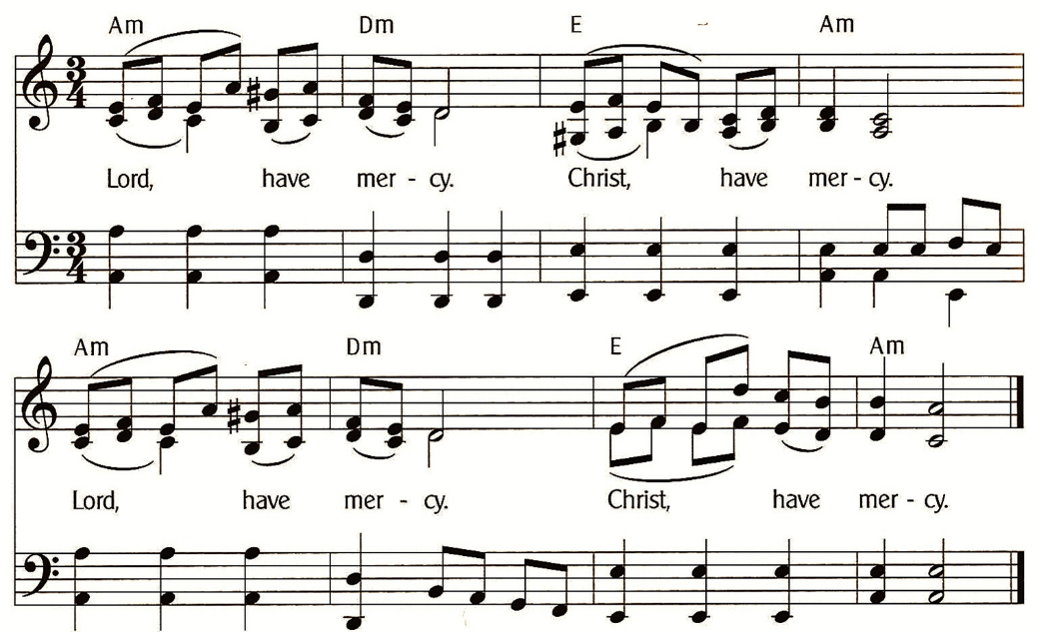

Gloria In Excelsis (Pastor Only) - Pg 23
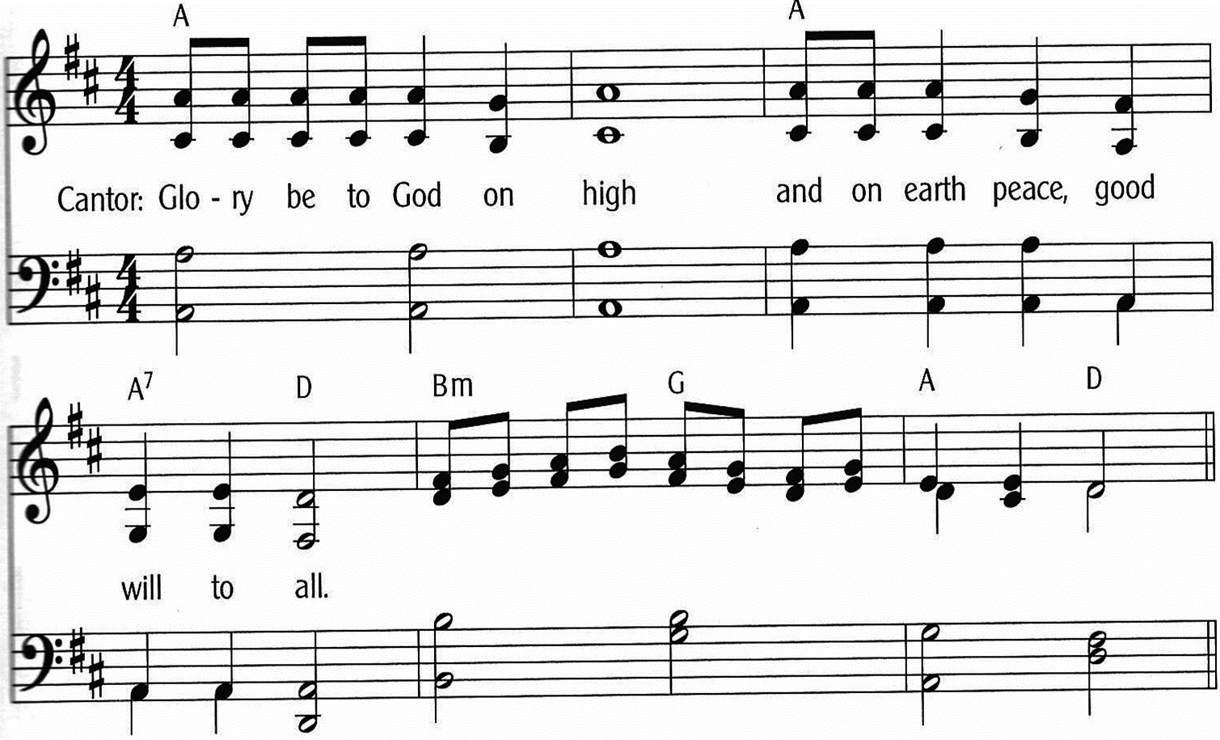
Page 3 of 12
Gloria In Excelsis - Pg 23-24
(Everyone Sing)
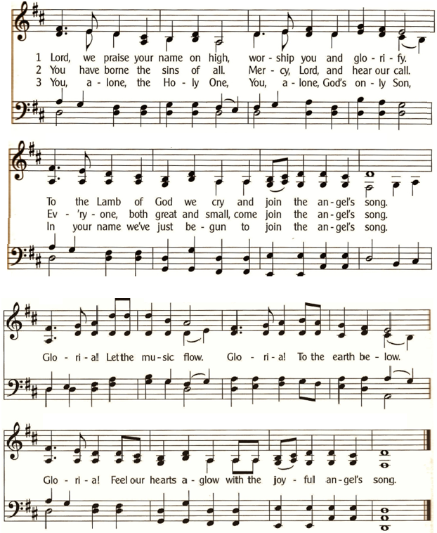

* Salutation - Pg 24
P: The Lord be with you.
C: And also with you.

Page 4 of 12
Prayer of the Day – Pg 24
P: Let us pray:
O God, by the humiliation of your Son, you raised up this fallen world. Teach us whom you have rescued from endless death to have the fullness of eternal joy, through the same Jesus Christ, your Son, our Lord. For he lives and reigns with you and the Holy Spirit, one God, now and forever. C: Amen.

Beautiful Savior #252

V1 Beau-ti-ful Sav-ior, King of Cre-a-tion,
Son of God and Son of Man.
Tru-ly I'd Love Thee, Tru-ly I'd Serve Thee,
Light of My Soul, My Joy, My Crown.

V2 Fair Are the Mead-ows, Fair Are the Wood-lands,
Robed in Flow'rs of Bloom-ing Spring.
Je-sus is Fair-er, Je-sus is Pur-er,
He Makes Our Sor-rowing Spir-it Sing.

V3 Fair is the Sun-shine, Fair is the Moon-light,
Bright the Spar-kling Stars on High.
Je-sus Shines Bright-er, Je-sus Shines Pur-er
Than All the An-gels in the Sky.

V4 Beau-ti-ful Sav-ior, Lord of the Na-tions,
Son of God and Son of Man.
Glo-ry and Hon-or, Praise, Ad-o-ra-tion,
Now and For-ev-er-more Be Thine.

Page 5 of 12
1st Lesson: Acts 3:11-21
¹¹While the lame man who had been healed clung to Peter and John, all the people, utterly astounded, ran together to them in the portico called Solomon’s. ¹²And when Peter saw it he addressed the people: “Men of Israel, why do you wonder at this, or why do you stare at us, as though by our own power or piety we have made him walk? ¹³The God of Abraham, the God of Isaac, and the God of Jacob, the God of our fathers, glorified his servant Jesus, whom you delivered over and denied in the presence of Pilate, when he had decided to release him. ¹⁴But you denied the Holy and Righteous One, and asked for a murderer to be granted to you, ¹⁵and you killed the Author of life, whom God raised from the dead. To this we are witnesses. ¹⁶And his name — by faith in his name — has made this man strong whom you see and know, and the faith that is through Jesus has given the man this perfect health in the presence of you all. ¹⁷And now, brothers, I know that you acted in ignorance, as did also your rulers. ¹⁸But what God foretold by the mouth of all the prophets, that his Christ would suffer, he thus fulfilled. ¹⁹Repent therefore, and turn back, that your sins may be blotted out, ²⁰that times of refreshing may come from the presence of the Lord, and that he may send the Christ appointed for you, Jesus, ²¹whom heaven must receive until the time for restoring all the things about which God spoke by the mouth of his holy prophets long ago.”
The Word of the Lord. C: Thanks be to God.

Psalm 4 (Read Responsively)

¹ Answer me when I call, O God, defender of my cause;
You set me free when I am hard-pressed;
Have mercy on me and hear my prayer.

² “You mortals, how long will you dishonor my glory;
How long will you worship dumb idols
And run after false gods?”
Page 6 of 12

³ Know that the Lord does wonders for the faithful;
When I call upon the Lord, he will hear me.

⁴ Tremble, then, and do not sin;
Speak to your heart in silence upon your bed.

⁵ Offer the appointed sacrifices
And put your trust in the Lord.
⁶ Many are saying, “Oh, that we might see better times!”
Lift up the light of your countenance upon us, O Lord.

⁷ You have put gladness in my heart,
More than when grain and wine and oil increase.

⁸ I lie down in peace; at once I fall asleep;
For only you, Lord, make me dwell in safety.

2nd Lesson: 1 John 3:1-7
¹See what kind of love the Father has given to us, that we should be called children of God; and so we are. The reason why the world does not know us is that it did not know him. ²Beloved, we are God’s children now, and what we will be has not yet appeared; but we know that when he appears we shall be like him, because we shall see him as he is. ³And everyone who thus hopes in him purifies himself as he is pure. ⁴Everyone who makes a practice of sinning also practices lawlessness; sin is lawlessness. ⁵You know that he appeared in order to take away sins, and in him there is no sin. ⁶No one who abides in him keeps on sinning; no one who keeps on sinning has either seen him or known him. ⁷Little children, let no one deceive you. Whoever practices righteousness is righteous, as he is righteous.
The Word of the Lord. C: Thanks be to God.

Hallelujah - Pg 25
Hal-le-lu, Hal-le-lu-Ia. Give Praise to the Lord
For the Bless-ings of Hea-ven in God’s Ho-ly Word.
For the Words of For-give-ness, the Words That En-dure.
Hal-le-lu, Hal-le-lu-Ia. Give Praise to the Lord.
Page 7 of 12
Gospel: Luke 24:36-49
The Gospel is written in the 24th Chapter of St Luke.
C: Glory be to you, O Lord.
³⁶As the disciples were talking about these things, Jesus himself stood among them, and said to them, “Peace to you!” ³⁷But they were startled and frightened and thought they saw a spirit. ³⁸And he said to them, “Why are you troubled, and why do doubts arise in your hearts? ³⁹See my hands and my feet, that it is I myself. Touch me, and see. For a spirit does not have flesh and bones as you see that I have.” ⁴⁰And when he had said this, he showed them his hands and his feet. ⁴¹And while they still disbelieved for joy and were marveling, he said to them, “Have you anything here to eat?” ⁴²They gave him a piece of broiled fish, ⁴³and he took it and ate before them. ⁴⁴Then he said to them, “These are my words that I spoke to you while I was still with you, that everything written about me in the Law of Moses and the Prophets and the Psalms must be fulfilled.” ⁴⁵Then he opened their minds to understand the Scriptures, ⁴⁶and said to them, “Thus it is written, that the Christ should suffer and on the third day rise from the dead, ⁴⁷and that repentance for the forgiveness of sins should be proclaimed in his name to all nations, beginning from Jerusalem. ⁴⁸You are witnesses of these things. ⁴⁹And behold, I am sending the promise of my Father upon you. But stay in the city until you are clothed with power from on high.”
The Gospel of the Lord. C: Praise to you, O Christ.

Page 8 of 12
Apostles’ Creed - Pg 28
I Believe in God, the Father Almighty,
Creator of Heaven and Earth.
I Believe in Jesus Christ, His Only Son, Our Lord.
He Was Conceived by the Power of the Holy Spirit
And Born of the Virgin Mary.
He Suffered Under Pontius Pilate,
Was Crucified, Died, and Was Buried. He Descended into Hell.
On the Third Day He Rose Again. He Ascended into Heaven,
And is Seated at the Right Hand of the Father.
He Will Come Again to Judge the Living and the Dead.
I Believe in the Holy Spirit, the Holy Christian Church,
The Communion of Saints, the Forgiveness of Sins,
The Resurrection of the Body, and the Life Everlasting. Amen.

****** Sermon: Rev John Saethre ******
Good Christian Friends, Rejoice and Sing #158
V1 Good Chris-tian Friends, Re-joice and Sing.
Now is the Tri-umph of Our King.
To All the World Glad News We Bring.
Al-le-lu-ia, Al-le-lu-ia, Al-le-lu-ia.
V2 The Lord of Life is Ris’n This Day.
Bring Flow’rs of Song to Strew His Way.
Let All the Earth Re-joice and Say.
Al-le-lu-ia, Al-le-lu-ia, Al-le-lu-ia.
V3 Praise We in Songs of Vic-to-ry
That Love, That Life Which Can-not Die,
And Sing with Hearts Up-lift-ed High.
Al-le-lu-ia, Al-le-lu-ia, Al-le-lu-ia.
V4 Your Name We Bless, O Ris-en Lord,
And Sing To-day with One Ac-cord,
The Life Laid Down, the Life Re-stored.
Al-le-lu-ia, Al-le-lu-ia, Al-le-lu-ia.

Page 9 of 12

Sharing the Peace
P: The peace of the Lord be with you always.
C: And also with you.

**** (Offerings Gathered & Presented) ****

Prayers of the Church – Pg 29
Let us pray for the whole people of God in Christ Jesus, and for all people according to their needs. (Brief Silence)
Help for the Blind
O Lord, open our eyes that we might see your power and glory. Encourage us to be helpers to the physically or spiritually blind, so all might come to see the goodness of your love. Help us all to see the love of God for us in Christ Jesus.
Lord, in your mercy, C: Hear our prayer.
For Every-day Miracles
Holy God, you work miracles every day. Sometimes those miracles are profound and defy logic and other times they are simple answers to prayers expressed in faith. Give us better understanding of your ways so we would see the every-day-miracles you perform around us.
Lord, in your mercy, C: Hear our prayer.
For the Church of Christ
Almighty God, pour out your Holy Spirit on the Church of Christ which is his precious bride. Give to your people the will to follow the Good Shepherd in word and deed, acting in kindness and trusting in his mercy in our lives and in the life of the church. Send us out into the world you love to make disciples of all nations.
Lord, in your mercy, C: Hear our prayer.

Page 10 of 12
For Suffering Everywhere
Heavenly Father, there are so many people around the world who are suffering from disease, hunger, poverty, or attacks from an enemy. Grant us strength and courage in the face of such trials. Give us hope in our hearts and let us pass that hope on for the stricken and dejected. We especially remember silently or aloud: [NAMES]
Lord, in your mercy, C: Hear our prayer.

P: Into your hands, almighty God, we commend all for whom we pray; trusting in your abundant mercy, through Jesus Christ, our Savior. C: Amen.

Lord’s Prayer - Pg 36
Our Father, Who Art in Heaven,
Hallowed Be Thy Name,
Thy Kingdom Come, Thy Will Be Done,
On Earth as it is in Heaven.
Give Us This Day Our Daily Bread.
And Forgive Us Our Trespasses,
As We Forgive Those Who Trespass Against Us.
And Lead Us Not into Temptation,
But Deliver Us From Evil.
For Thine is the Kingdom,
And the Power, and the Glory,
Forever and Ever. Amen
*Benediction – Pg 38
P: As you go, may God go with you;
May He go before you to show you the way;
May He go behind you encourage you;
May He go beside you to befriend you;
Above you to watch over you;
And within you to grant you His eternal peace.
In the Name of the Father, and of the Son,
and of the Holy Spirit. C: Amen.
Page 11 of 12
All Creatures of Our God and King #20 (V.1,7)

V1 All Crea-tures of Our God and King,
Lift Up Your Voice with us and Sing,
" Al-le-lu-ia. Al-le-lu-ia."
O Burning Sun with Gold-en Beam,
Thou Silver Moon with Soft-er Gleam,
O Praise Him, O Praise Him.
Al-le-lu-ia, Al-le-lu-ia, Al-le-lu-ia.

V7 Let All Things Their Cre-a-tor Bless,
And Wor-ship God in Hum-ble-ness.
Oh, Praise Him. Al-le-lu-ia.
Oh, Praise the Fa-ther, Praise the Son,
And Praise the Spir-it, Three in One.
O Praise Him, O Praise Him.
Al-le-lu-ia, Al-le-lu-ia, Al-le-lu-ia.

Dismissal
P: Go in Peace, Serve the Lord.
C: Thanks be to God!

Postlude

Page 12 of 12
Welcome To Emmanuel Lutheran – N.A.L.C.
Thanks for worshiping with us this evening. Your presence is your gift to us. We pray that our Service of Worship is a blessing to you. Sealed by the Holy Spirit and marked with the cross of Christ forever we are -- praising, proclaiming and practicing -- Emmanuel, God with us, in daily life!

Emmanuel Lutheran Church Emmanuel North
3819 - 18th Avenue NW 1965 Emmanuel Dr NW
Rochester, MN 55901 (7601 - 18th Ave NW)
Phone: 507-206-3048
Website: www.emmanuelofrochester.org
Email Address: EmmanuelRochesterNALC@gmail.com
Facebook page: Emmanuel Lutheran Church of Rochester, MN

Men’s Bible Study
Men meet at Oasis Church each Wednesday at 11am, Apr 17th & 24th and May 1st, 8th, 15th, 22nd & 29th studying Scripture.

Women’s Bible Study
Women meet at Oasis Church every other Wednesday at 1pm, Apr 24th to study “Chasing Vines” by Beth Moore.

Thrivent Choice Dollars
If You Have Thrivent Products, go Online to www.thrivent.org or Call 1-800-847-4836 to Designate Your “Choice Dollars”.

Calendar Items
Wed, Apr 17 Men’s Bible Study - 11am at Oasis
Sat, Apr 20 Eve of Easter 4 Service w/Communion - 4pm Wed, Apr 24 Men’s Bible Study - 11am at Oasis
-and- Women’s Bible Study – 1pm at Oasis
Sat, Apr 27 Eve of Easter 5 Worship Service - 4pm
Wed, May 1 Men’s Bible Study - 11am at Oasis
Sat, May 4 Eve of Easter 6 Service w/Communion - 4pm Wed, May 8 Men’s Bible Study - 11am at Oasis
-and- Women’s Bible Study – 1pm at Oasis
Sat, May 11 Ascension / Easter 7 Worship Service - 4pm
Wed, May 15 Men’s Bible Study - 11am at Oasis
Sat, May 18 Eve of Pentecost Service w/Communion 4pm Wed, May 22 Men’s Bible Study - 11am at Oasis
-and- Women’s Bible Study – 1pm at Oasis
Sat, May 25 Eve of Holy Trinity Worship Service - 4pm
Mon, May 27 MEMORIAL DAY
Wed, May 29 Men’s Bible Study - 11am at Oasis
Sat, Jun 1 Eve of Pentecost 2 Service w/Communion 4pm

