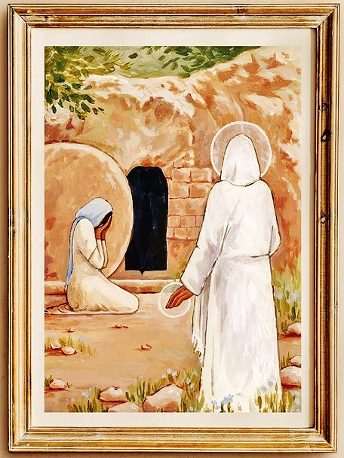

Page 16 of 16
Worship: Easter Sunday Sun, Mar 31st, 2024 – 10am
Pastor: Rev John Saethre Lutheran Book of Worship
Pianist: MarJean Damerval - Setting II w/Communion
Reader: Lee Pearce * indicates stand if able

Gathering Hymn: Were You There #92 (V.1,4)
Verse 1
Were You There When They Cru-ci-fied My Lord?
Were You There When They Cru-ci-fied My Lord?
Oh, Some-times it Causes Me to Trem-ble, Trem-ble, Trem-ble.
Were You There When They Cru-ci-fied My Lord?
Verse 4
Were You There When God Raised Him from the Tomb?
Were You There When God Raised Him from the Tomb?
Oh, Some-times it Causes Me to Trem-ble, Trem-ble, Trem-ble.
Were You There When God Raised Him from the Tomb?

Confession & Forgiveness
P: Christ is Risen!
C: He is risen, indeed! Alleluia!

P: The grace of our Lord Jesus Christ, the Lamb of God who went to the cross for our sake; the love of the Father who put an end to the power of death through the resurrection of Christ; and the promised Holy Spirit who gathers us together, be with you all.
C: And also with you.
(Silence for self-reflection and examination)

Page 1 of 16
P: Lord of heaven and earth, of the living and of the dead,
C: We come before you confessing our sins, asking for your gracious mercy. By our human nature we are sinful & unclean; we have sinned against you in thought, word, and deed. By your lovingkindness, we implore you to grant us forgiveness and restore us to your salvation, that we might live holy lives here and now, and be with you in the final resurrection. Amen.

P: Through the gift of the Holy Spirit, God declares to all who believe and confess their sins, that we are forgiven and restored to a right relationship through Jesus Christ. We have been redeemed and renewed by Christ, our Passover Lamb. In the name of the Father, and of the Son, and of the Holy Spirit, let us walk in newness of life, following our Lord Jesus in holy obedience. C: Amen.

Hymn: Jesus Christ is Risen Today #151

V1 Je-sus Christ is Ris'n Today, Al-le-lu-Ia.
Our Tri-um-phant Ho-ly Day, Al-le-lu-Ia.
Who Did Once Up-on the Cross, Al-le-lu-Ia.
Suf-fer to Re-deem Our Loss. Al-le-lu-Ia.

V2 Hymns of Praise Then Let us Sing, Al-le-lu-Ia.
Un-to Christ, Our Heav'n-ly King, Al-le-lu-Ia.
Who En-dured the Cross and Grave, Al-le-lu-Ia.
Sin-ners to Re-deem and Save. Al-le-lu-Ia.

V3 But the Pains Which He En-dured, Al-le-lu-Ia.
Our Sal-va-tion Have Pro-cured. Al-le-lu-Ia.
Now A-bove the Sky He's King, Al-le-lu-Ia.
Where the An-gels Ev-er Sing. Al-le-lu-Ia.

V4 Sing We to Our God A-bove, Al-le-lu-Ia.
Praise E-ter-nal as His Love; Al-le-lu-Ia.
Praise Him, All You Heav'n-ly Host, Al-le-lu-Ia.
Father, Son, and Ho-ly Ghost. Al-le-lu-Ia.

Page 2 of 16
*Greeting
P: Hallelujah! Christ is Risen!
C: He is risen, indeed! Alleluia!

P: The grace of our Lord Jesus Christ, the Lamb of God who went to the cross for our sake; the love of the Father who put an end to the power of death through the resurrection of Christ; and the promised Holy Spirit who gathers us together, be with you all.
C: And also with you.

*Kyrie – Pg 78-79
P: In Peace Let Us Pray to the Lord.
C: Lord, Have Mer-cy.

P: For the Peace from A-bove,
And for Our Sal-va-tion, Let Us Pray to the Lord.
C: Lord, Have Mer-cy.

P: For the Peace of the Whole World,
For the Well-Being of the Church of God,
And for the Uni-ty of All, Let Us Pray to the Lord.
C: Lord, Have Mer-cy.

P: For This Holy House, and For All Who Offer Here
Their Wor-ship and Praise, Let Us Pray to the Lord.
C: Lord, Have Mer-cy.

P: Help, Save, Comfort, & De-fend Us, Gra-cious Lord.
C: A-men.

Page 3 of 16
Hymn of Praise – Pg 81-82
P: This is the Feast of Vic-to-ry for Our God, Al-le-lu-ia
C: Wor-thy is Christ, The Lamb Who Was Slain,
Whose Blood Set Us Free to Be Peo-ple of God,
Pow-er and Rich-es and Wis-dom and Strength,
And Hon-or and Bless-ing and Glo-ry Are His.
This is the Feast of Vic-to-ry for Our God.
Al-le-lu-ia.
Sing with All the Peo-ple of God
And Join in the Hymn of All Cre-a-tion.
Bless-ing and Hon-or and Glo-ry and Might
Be to God and the Lamb For-ev-er. A-men.
This is the Feast of Vic-to-ry for Our God,
For the Lamb Who Was Slain Has Be-gun His Reign
Al-le-lu-ia, Al-le-lu-ia.

* Salutation – Pg 82
P: The Lord be with you.
C: And also with you.

Prayer of the Day – Pg 82
P: Let us pray: Almighty God, you have overcome death through your only-begotten Son, Jesus Christ, and have opened to us the gate of everlasting life. We humbly beseech you that as you put into our minds good desires, so by your continual help we may bring them to good effect; through Jesus Christ, our Lord, who lives and reigns with you and the Holy Spirit, one God, now and forever. C: Amen.

1st Reading: Isaiah 25:6-9
⁶On this mountain the Lord of hosts will make for all peoples a feast of rich food, a feast of well-aged wine, of rich food full of marrow, of aged wine well refined. ⁷And he will swallow up on this mountain the covering that is cast over all peoples, the veil that is spread over all nations. ⁸He will swallow up death forever; and the Lord God will wipe away tears from all faces,

Page 4 of 16
and the reproach of his people he will take away from all the earth, for the Lord has spoken. ⁹It will be said on that day, “Behold, this is our God; we have waited for him, that he might save us. This is the Lord; we have waited for him; let us be glad and rejoice in his salvation.”
The Word of the Lord. C: Thanks be to God.

Psalm 16 (Read Responsively)

¹ Protect me, O God, for I take refuge in you;
I have said to the Lord,
“You are my Lord, my good above all other.”

² All my delight is upon the godly that are in the land,
Upon those who are noble among the people.

³ But those who run after other gods
Shall have their troubles multiplied.

⁴ Their libations of blood I will not offer,
Nor take the names of their gods upon my lips.

⁵ O Lord, you are my portion and my cup;
It is you who uphold my lot.

⁶ My boundaries enclose a pleasant land;
Indeed, I have a goodly heritage.

⁷ I will bless the Lord who gives me counsel;
My heart teaches me, night after night.

⁸ I have set the Lord always before me;
Because he is at my right hand I shall not fall.

⁹ My heart, therefore, is glad, and my spirit rejoices;
My body also shall rest in hope.

¹⁰ For you will not abandon me to the grave,
Nor let your holy one see the Pit.

¹¹ You will show me the path of life;
In your presence there is fullness of joy,
And in your right hand are pleasures forevermore.

Page 5 of 16
2nd Reading: 1 Corinthians 15:1-11
¹Now I would remind you, brothers, of the gospel I preached to you, which you received, in which you stand, ²and by which you are being saved, if you hold fast to the word I preached to you — unless you believed in vain. ³For I delivered to you as of first importance what I also received: that Christ died for our sins in accordance with the Scriptures, ⁴that he was buried, that he was raised on the third day in accordance with the Scriptures, ⁵and that he appeared to Cephas, then to the twelve. ⁶Then he appeared to more than five hundred brothers at one time, most of whom are still alive, though some have fallen asleep.
⁷Then he appeared to James, then to all the apostles. ⁸Last of all, as to one untimely born, he appeared also to me. ⁹For I am the least of the apostles, unworthy to be called an apostle, because I persecuted the church of God. ¹⁰But by the grace of God I am what I am, and his grace toward me was not in vain.
On the contrary, I worked harder than any of them, though it was not I, but the grace of God that is with me. ¹¹Whether then it was I or they, so we preach and so you believed.
The Word of the Lord. C: Thanks be to God.

*Gospel Verse: “Al-le-lu-ia” – Pg 83
Al-le-lu-ia, Lord, to Whom Shall We Go?
You Have the Words of E-ter-nal Life, Al-le-lu-ia.

*Gospel: Mark 16:1-8
The Holy Gospel According to St Mark, the 16th Chapter
C: Glory to you, O Lord.
¹When the Sabbath was past, Mary Magdalene, Mary the mother of James, and Salome bought spices, so that they might go and anoint him. ²And very early on the first day of the week, when the sun had risen, they went to the tomb. ³And they were saying to one another, “Who will roll away the stone for us from the entrance of the tomb?” ⁴And looking up, they saw that the stone had been rolled back — it was very large.

Page 6 of 16
⁵And entering the tomb, they saw a young man sitting on the right side, dressed in a white robe, and they were alarmed. ⁶And he said to them, “Do not be alarmed. You seek Jesus of Nazareth, who was crucified. He has risen; he is not here. See the place where they laid him. ⁷But go, tell his disciples and Peter that he is going before you to Galilee. There you will see him, just as he told you.” ⁸And they went out and fled from the tomb, for trembling and astonishment had seized them, and they said nothing to anyone, for they were afraid.
The Gospel of the Lord. C: Praise to you, O Christ.

*** Children’s Sermon: Rev John Saethre ***

****** Sermon: Rev John Saethre ******

Hymn of the Day: Thine is the Glory #145

V1 Thine is the Glo-ry, Ris-en, Con-qu'ring Son.
End-less is the Vic-t’ry, Thou O'er Death Hast Won.
An-gels in Bright Rai-ment Rolled the Stone A-way,
Kept the Fold-ed Grave Clothes Where Thy Bod-y Lay.
Thine is the Glo-ry, Ris-en Con-qu'ring Son.
End-less is the Vic-t'ry, Thou O'er Death Hast Won.

V2 Lo, Je-sus Meets Thee, Ri-sen from the Tomb.
Lov-ing-ly He Greets Thee, Scat-ters Fear and Gloom.
Let His Church with Glad-ness Hymns of Tri-umph Sing,
For the Lord Now Liv-eth. Death Hath Lost its Sting.
Thine is the Glo-ry, Ris-en Con-qu'ring Son.
End-less is the Vic-t'ry, Thou O'er Death Hast Won.

V3 No More We Doubt Thee, Glo-rious Prince of Life.
Life is Nought With-out Thee. Aid us in Our Strife.
Make us More Than Con-qu'rors, Thru Thy Death-less Love.
Bring us Safe Through Jor-dan To Thy Home A-bove.
Thine is the Glo-ry, Ris-en Con-qu'ring Son.
End-less is the Vic-t'ry, Thou O'er Death Hast Won.

Page 7 of 16
*Confession of Faith: Apostles’ Creed Pg 85
I Believe in God, the Father Almighty,
Creator of Heaven and Earth.
I Believe in Jesus Christ, His Only Son, Our Lord.
He Was Conceived by the Power of the Holy Spirit
And Born of the Virgin Mary.
He Suffered Under Pontius Pilate,
Was Crucified, Died, and Was Buried. He Descended into Hell.
On the Third Day He Rose Again. He Ascended into Heaven,
And is Seated at the Right Hand of the Father.
He Will Come Again to Judge the Living and the Dead.
I Believe in the Holy Spirit, the Holy catholic Church,
The Communion of Saints, the Forgiveness of Sins,
The Resurrection of the Body, and the Life Everlasting.
Amen.

The Prayers of the Church – Pg 85
A: Let us pray for the whole people of God in Christ Jesus, and for all people according to their needs. (A brief silence)
For Spreading the News of Christ
Almighty God, you have fought to restore us to a right relationship with you for many generations, and with Christ Jesus winning the victory over sin and death you have done that forever. Help us Lord, to tell the story of your victory and give thanks for it daily so our daughters and sons may know your steadfast kindness and live in the sure and certain hope of the resurrection.
Lord, in your mercy, C: Hear our prayer.
For Easter Victory
Lord God, on this day you have broken the bonds of death and have risen victorious over the power of the grave and are alive forever. We give you thanks and praise for your gift of forgiveness and new life. By your grace, grant that each day the sinner in us may be put to death and the new self be raised to live with you in righteousness and faith.
Lord, in your mercy, C: Hear our prayer.
Page 8 of 16
For Those New in the Faith
Heavenly Father, on this day when the celebration of your redeeming work in Jesus the Christ is at its highest point, strengthen and sustain those whose faith is tender and new. Help them to see in your church’s witness a new vision of life in which grace and mercy are its guides.
Lord, in your mercy, C: Hear our prayer.
For the Hope and Promise of the Resurrection
Ever-living God, strengthen us, and especially all who mourn, by the promise of new life with Christ. May hope in the resurrection and the promise of eternal life help us live in confidence knowing we will see our loved ones again on that day when Jesus returns.
Lord, in your mercy, C: Hear our prayer.

P: Into your hands, O Lord, we commend all for whom we pray, trusting in your mercy. through you Son, Jesus Christ, our Lord. C: Amen.

Sharing the Peace – Pg 86

P: The peace of the Lord be with you. C: And also with you.

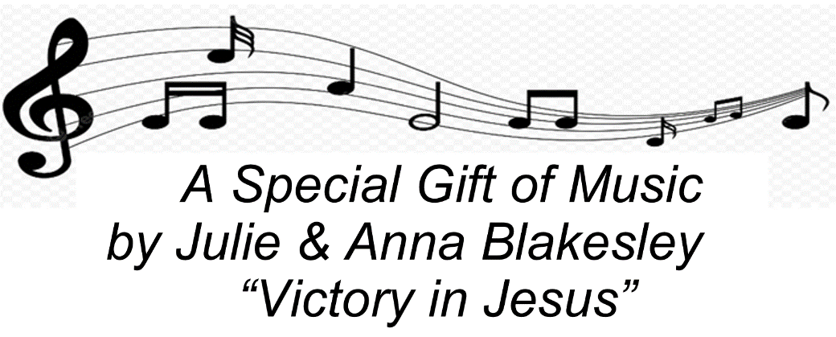

***** Offerings Gathered & Presented ****

Page 9 of 16
Offertory Hymn– Pg 86
Let the Vine-yards Be Fruit-ful, Lord
And Fill to the Brim Our Cup of Bless-ing.
Gath-er a Har-vest from the Seeds That Were Sown,
That We May Be Fed with the Bread of Life.
Gath-er the Hopes and Dreams of All.
U-nite Them with the Prayers We Of-fer.
Grace Our Ta-ble with Your Pres-ence,
And Give us a Fore-taste of the Feast to Come.

Prayer of Thanks– Pg 87
P: Let us pray: Merciful God,
C: We offer with joy and thanksgiving what you have first given us — ourselves, our time, and our possessions — signs of your gracious love. Receive them for the sake of him who offered himself for us, Jesus Christ our Lord. Amen.

The Great Thanksgiving– Pg 88
P: The Lord be with you.
C: And also with you.
P: Lift up your hearts.
C: We lift them to the Lord.
P: Let us give thanks to the Lord, our God
C: It is right to give him thanks and praise.
P: It is indeed right and salutary that we should at all times and in all places offer thanks and praise to you, O Lord, holy Father, almighty and ever-living God. But chiefly we are bound to praise you for the glorious resurrection of our Lord; for he is the true Passover Lamb who gave himself to take away our sin, who by his death has destroyed death, and by his rising has brought us to eternal life. And so, with Mary Magdalene and Peter and all the witnesses of the resurrection, with earth and sea and all their creatures, and with angels and archangels, cherubim and seraphim, we praise your name and join their unending hymn: 10
Unending Hymn– Pg 89
C: Ho-ly, ho-ly, ho-ly Lord, God of pow-er and might.
Hea-ven and earth are full of your glo-ry,
Ho-san-na in the high-est.
Bless-ed is he who comes in the name of the Lord
Ho-san-na in the high-est.
Ho-san-na in the high-est.

*Eucharistic Prayer– Pg 89
In the night in which he was betrayed, our Lord Jesus took bread, and gave thanks, broke it and gave it to his disciples, saying, “Take and eat, this is my body, given for you. Do this for the remembrance of me.”
Again, after supper, he took the cup, gave thanks, and gave it for all to drink, saying, “This cup is the new covenant in my blood, shed for you and for all people for the forgiveness of sin. Do this for the remembrance of me.” C: Amen.

*Lord’s Prayer: Traditional Version – Pg 91
Our Father, Who Art in Heaven,
Hallowed Be Thy Name,
Thy Kingdom Come, Thy Will Be Done,
On Earth as it is in Heaven.
Give Us This Day Our Daily Bread.
And Forgive Us Our Trespasses,
As We Forgive Those Who Trespass Against Us.
And Lead Us Not into Temptation,
But Deliver Us from Evil.
For Thine is the Kingdom,
And the Power, and the Glory,
Forever and Ever. Amen.

Page 11 of 16
Communion Hymn: Lamb of God – Pg 92
Lamb of God, You Take A-way the Sin of the World,
Have Mer-cy on us.
Lamb of God, You Take A-way the Sin of the World,
Have Mer-cy on us.
Lamb of God, You Take A-way the Sin of the World,
Grant us Peace, Grant us Peace.

Communion Institution– Pg 92
P: The body of Christ, given for you.
P: The blood of Christ, shed for you.

*Table Blessing– Pg 92
The body and blood of our Lord Jesus Christ strengthen you and keep you in his grace.
C: Amen.

*Canticle: Thankful Hearts – Pg 92-93
Thank-ful Hearts and Voic-es Raise,
Tell Ev-‘ry-one What God Has Done.
Let All Who Seek the Lord Re-joice
And Bear Christ’s Ho-ly Name
Send us With Your Prom-is-es, O God
And Lead us Forth in Joy
With Shouts of Thanks-giv-ing. Al-le-lu-ia.

Post Communion Prayer– Pg 94
P: Let us pray:
Pour out upon us the spirit of your love, O Lord, and unite the wills of those whom you have fed with one heavenly food. through Jesus Christ, our Lord. C: Amen.

Page 12 of 16
*Benediction – Pg 95
P: As you go, may God go with you;
May He go before you to show you the way;
May He go behind you encourage you;
May He go beside you to befriend you;
Above you to watch over you;
And within you to grant you His eternal peace.
In the Name of the Father, and of the Son,
and of the Holy Spirit. C: Amen.

Now All the Vault of Heaven Resound #143 (V.1,4)
Verse 1
Now All the Vault of Heav'n Re-sounds
In Praise of Love That Still A-bounds,
"Christ Has Tri-umphed, He is Liv-ing."
Sing, Choirs of An-gels, Loud and Clear,
Re-peat Their Song of Glo-ry Here,
"Christ Has Tri-umphed, Christ Has Tri-umphed."
Al-le-lu-ia, Al-le-lu-ia, Al-le-lu-ia.
Verse 4
A-dor-ing Prais-es Now We Bring
And with the Heav'n-ly Bless-ed Sing,
"Christ Hath Tri-umphed, Al-le-lu-ia."
Be to the Fa-ther, and Our Lord,
To Spir-it Blest, Most Ho-ly God,
All the Glo-ry, Nev-er End-ing.
Al-le-lu-ia, Al-le-lu-ia, Al-le-lu-ia.

Dismissal– Pg 95
P: Hallelujah! Go in peace. Christ is Risen!
C: He is risen, indeed! Alleluia!
Thanks be to God!

Postlude

Page 13 of 16
Welcome To Emmanuel Lutheran – N.A.L.C.
Thanks for worshiping with us this evening. Your presence is your gift to us. We pray that our Service of Worship is a blessing to you. Sealed by the Holy Spirit and marked with the cross of Christ forever we are -- praising, proclaiming and practicing -- Emmanuel, God with us, in daily life!

Emmanuel Lutheran Church Emmanuel North
3819 - 18th Avenue NW 1965 Emmanuel Dr NW
Rochester, MN 55901 (7601 - 18th Ave NW)
Phone: 507-206-3048
Website: www.emmanuelofrochester.org
Email Address: EmmanuelRochesterNALC@gmail.com
Facebook page: Emmanuel Lutheran Church of Rochester, MN

Men’s Bible Study
Men meet at Oasis Church each Wednesday at 11am, Apr 3rd, 10th, 17th & 24th and May 1st, 8th, 15th, 22nd & 29th studying Scripture.

Women’s Bible Study
Women meet at Oasis Church every other Wednesday at 1pm, Apr 10th & 24th to study “Chasing Vines” by Beth Moore.

Thrivent Choice Dollars
If You Have Thrivent Products, go Online to www.thrivent.org or Call 1-800-847-4836 to Designate Your “Choice Dollars”.
NOTE: This must be done TODAY or it is lost.

Page 14 of 16
Calendar Items
Wed, Apr 3 Men’s Bible Study - 11am at Oasis
Sat, Apr 6 Eve of Easter 2 Service w/Communion - 4pm
Wed, Apr 10 Men’s Bible Study - 11am at Oasis
-and- Women’s Bible Study – 1pm at Oasis
Sat, Apr 13 Eve of Easter 3 Worship Service - 4pm
Wed, Apr 17 Men’s Bible Study - 11am at Oasis
-and- Women’s Bible Study – 1pm at Oasis
Sat, Apr 20 Eve of Easter 4 Service w/Communion - 4pm
Wed, Apr 24 Men’s Bible Study - 11am at Oasis
Sat, Apr 27 Eve of Easter 5 Worship Service - 4pm
Wed, May 1 Men’s Bible Study - 11am at Oasis
-and- Women’s Bible Study – 1pm at Oasis
Sat, May 4 Eve of Easter 6 Service w/Communion - 4pm
Wed, May 8 Men’s Bible Study - 11am at Oasis

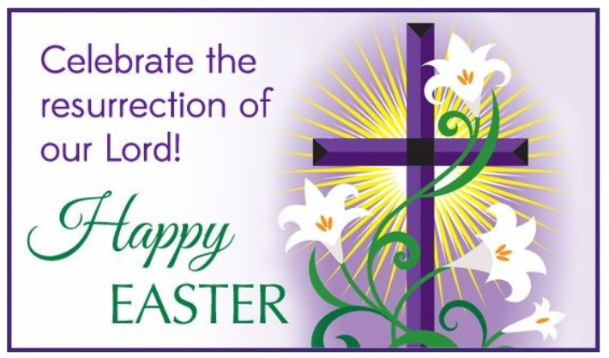

Page 15 of 16

